

LIP-8040L
User Guide

Revision History

Issue | Date | Remark
1 | Aug. 08 | Initial Release

 | Disposal of your old appliance  1. When the crossed-out wheeled bin symbol is attached to a product, it means the product is covered by the European Directive 2002/96/EC.  2. All electrical and electronic products should be disposed of separately from the municipal waste stream via designated collection facilities appointed by government or the local authorities.  The correct disposal of your old appliance will help prevent potential negative consequences for the environment and human health.  4. For more detailed information about disposal of your old appliance, please contact your city office, waste disposal service or the shop where you purchased the product.

Important Safety Information
To prevent unexpected danger or damage please read this information before installing or attempting to repair you phone. Warning and Caution information is provided to alert the consumer of known dangers:

Warning: To reduce the possibility of electric shock, do not expose your phone to high humidity areas, such as a bathroom, swimming area, etc.
Caution: Use only LG-Nortel approved batteries and desktop chargers to avoid the damage to the phone. Using other batteries or chargers voids your warranty and may cause an explosion.
1. Only trained and qualified service personnel shall install, replace or service the phone.  2. Do not spill liquid life water on the phone. If so, call the service center as this may result in fire or electric shock.  3. If you see smoke or smell something during use, unplug the power cord and the phone line. Call the service center immediately.  4. If the power adapter is used, do not touch the plug with wet hands. This may result in a fire or an electric shock or equipment damage.  6. Do not use the phone during a thunderstorm. Lightning strike may result in fire, severe electrical or acoustic shock.  7. Do not use the power adapter if the power cord or wall outlet is damaged. This may result in fire or an electric shock. | 1. Ensure that children do not pull on phone cords. This may injure children or result in equipment damage.  2. The ear-piece houses a magnetic device which may attract pins or small metal objects. Keep headset clear of such objects and check before use.  3. Avoid placing the phone in an area that is excessively dusty, damp or subject to vibration.  4. Choose a site for the phone that is well-ventilated and dry.  5. Do not plug multiple plug-packs into one power outlet. This may result in the plug overheating and may result in a fire or plug pack failure.  6. Do not put heavy things on the phone.  7. Do not drop or throw the phone.  8. Static electricity discharge will damage electronic components.  9. Keep out of direct sunlight and away from heat.  10. No user-serviceable parts inside. Do not insert a screwdriver or any metal objects into the phone. This may cause electric shock or damage the equipment and will render the warranty void.  11. Clean the phone with a soft, dry cloth only. Do not use volatile liquids such as petrol, alcohol, or acetone as this may cause a fire or result in discoloration or damage to plastics. Do not clean with wax or silicon products as these may enter the equipment and cause operation to become unstable.

TABLE OF CONTENTS

1. Introduction 1
1.1 General 1
1.2 Feature Information 1
1.3 Feature Groupings 1
1.4 iPECS LIP-8040L Phone Description 2
1.5 LIP-8040L Phone Installation 3
1.5.1 Power 4
1.5.2 Wall Mount 4
2. LCD, Speakerphone & Related Features 6
2.1 Using the LCD 6
2.2 Display Menu 6
2.2.1 Phone Setting 8
2.2.2 Conference Room 9
2.2.3 ICM SMS 10
2.2.4 Network Config 11
2.2.5 Attendant menu 12
2.3 Using the Speakerphone 12
2.4 Using a Bluetooth Wireless Headset 13
2.5 Using a Serial DSS 15
3. Receiving calls 18
3.1 Answering a Call While Idle 18
3.2 Responding to a Call While Busy 19
3.3 Using Answering Machine Emulation (AME) 19
3.4 Differential Ring Signals 20
3.5 Answering Calls at Night 22
3.6 Answering Calls to Other Stations 22
3.7 Using Do-Not-Disturb (DND) to Block Incoming Calls 22
3.8 Forwarding Calls 23
3.8.1 Forwarding calls to another Station or Voice Mail 23
3.8.2 Forwarding calls to an external number 24
3.8.3 Forwarding callers to a Text Message 26
4. Placing a call 30
4.1 Internal Calls 30
4.1.1 Using Camp-On when calling a busy station 30
4.1.2 Leaving a Message Wait 31
4.2 External Calls 31
4.2.1 Placing external CO/VoIP calls 31
4.2.2 Waiting for the next available CO/IP line 33
4.2.3 Account Codes: Tracking External calls for billing 33
4.2.4 Disable dialing from your phone 33
4.2.5 Temporarily override dialing restrictions at a phone 34
4.3 Using Directory 34
4.3.1 Using Last Number Redial (LNR) 34
4.3.2 Using and Entering Saved Number Dial 35
4.3.3 Using System Speed Dial Numbers 36
4.3.4 Using and Entering Station Speed Dial Numbers 36
4.3.5 Using Dial by Name and Entering Your Name 39
4.3.6 Using Automatic Called Number Redial (ACNR) 40
5. Transfer, Conference & Other Call Handling 42
5.1 Call Transfer: Sending a call to a different destination 42
5.2 Call Hold: Placing a call in a waiting state 42
5.3 Broker Call: Switching between two calls 43
5.4 Joining Multiple People in a Conference 43
5.4.1 Setting up a Conference Room 44
5.5 Call Park: Placing a call on Hold to Page 45
5.6 Two-Way Record: Recording a call 46
6. Send & Retrieve Messages 47
6.1 Responding to a Station Message Waiting Indication 47
6.2 Getting Voice Mail Messages 48
6.3 Sending and Receiving Short Text Messages 49
7. Remote System Access 51
7.1 Direct Inward System Access (DISA) 51
7.2 Mobile Phone Extension 51
8. Misc. Features 54
8.1 Call Log 54
8.2 Contrast 56
8.3 Background Music and Music on Hold 56
8.4 Using Internal, External and Meet-Me Paging 57
8.5 Push-To-Talk (PTT) Page 58
8.6 Wake-Up Alarm 58
8.7 Alarm/Door Bell 59
8.8 Power Fail Transfer (PFT) 59
8.9 System Voice Memo 59
8.10 Hot Desk 60
9. PBX, Centrex & ISDN features 62
9.1 Access PBX or Centrex features 62
9.2 Access the ISDN Network 62
9.2.1 Using the Keypad facility to access ISDN features 62
9.2.2 Using ISDN Supplementary Services 63
9.2.3 Activating ISDN Caller ID Restriction 63
10. Features & Flex buttons 64
10.1 Entering Station Program Data 64
10.2 Assigning Features to Flex Buttons 64
Appendix A Flexible Numbering Plan 65
Appendix B User Program Codes 71

1. Introduction

Introduction

General
Your telephone is connected to an advanced-technology, highly-versatile, fully-featured telecom system designed to make office communications easy and productive. Employing state-of-the-art Voice over Internet Protocol (VoIP) technology, voice and data converge on a single IP packet network. Because each iPECS Phone is an IP appliance, it can be moved easily throughout the office LAN and maintain normal operation.

Feature Information
We have taken every effort to make this user guide simple and straightforward. The guide starts with the simpler operations of the iPECS Phone Speakerphone, moves on to receiving and placing calls, and then to more advanced features. Each section includes a brief and basic description of each feature and step-by-step operation instructions.

The operations shown in this guide use the System’s base default Numbering Plan. Your specific Numbering Plan may be different. Some features may not be available for you to access or may be subject to certain limitations based on the set-up of the System (refer to your System Administrator, or the iPECS Technical Manuals for further information).

NOTE—Under certain operating conditions, this equipment may not be able to make emergency calls. Alternative arrangements should be made for access to emergency services.

Feature Groupings
Every effort has been taken to divide the features into a logical and consistent sequence so that features can be quickly located.

Features have been divided into groups, Receiving Calls, Placing Calls, etc. Within each group, features are arranged according to the difficulty of operation and frequency of use.

iPECS LIP-8040L Phone Description
The iPECS LIP-8040DL Phone (shown) incorporate the latest in VoIP technology and user interface to provide you with a cost effective, simple to use, productive communications tool. It includes a large 9-line 24-character per line LCD (refer to Phone Diagrams, next page). The bottom line of the display incorporates an interactive menu accessed with the 3 Soft buttons just below the display. The Navigation button in the lower center of the Phone allows you to move through the menu choices when more than three selections are available.

Features and functions of your iPECS are accessed either using the Fixed or Flexible buttons or by selecting a menu item using the Soft buttons. In the remainder of this User Guide, the Fixed or Flexible buttons are shown with a box surrounding the button designation while Soft button menu selections are shown with a double underline.

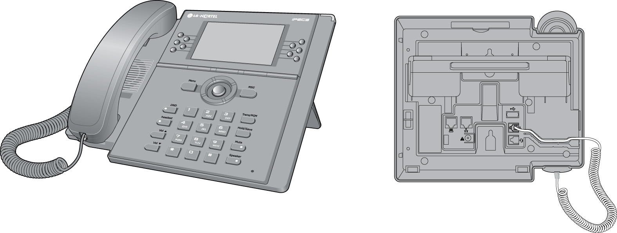

iPECS LIP-8040L Front and Back View

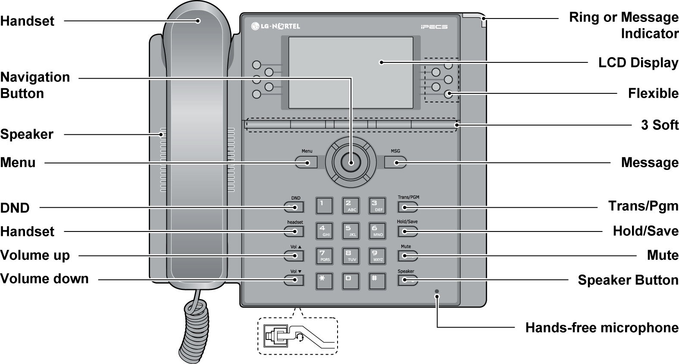

iPECS LIP-8040L Diagram

LIP-8040L Phone Installation
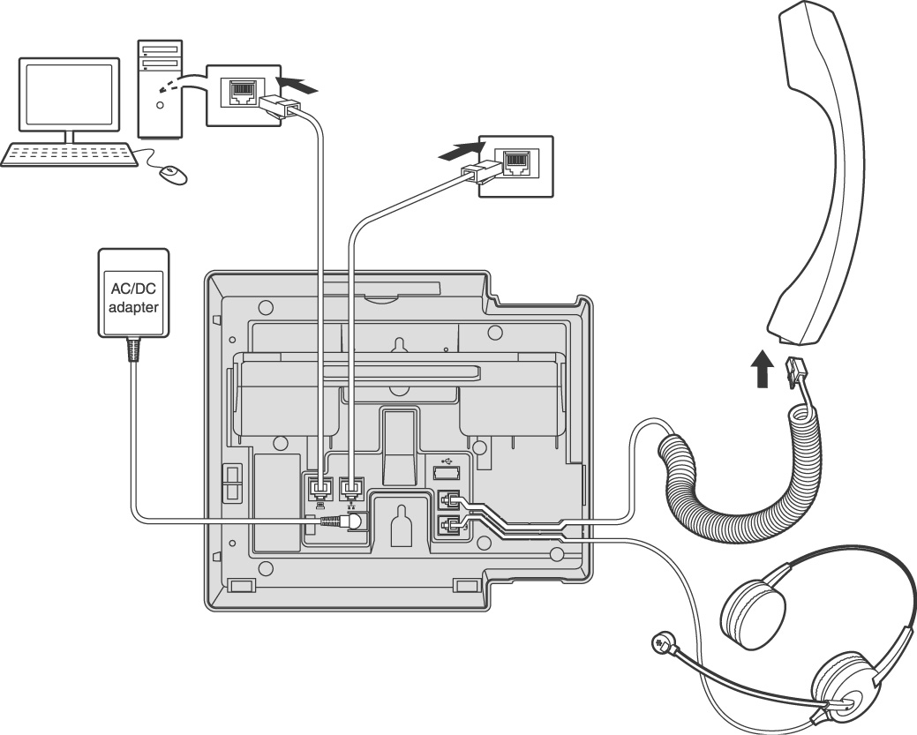
The phone handset is attached as shown (A). The LIP-8040L has 2 RJ-45 and 10/100 Base-T LAN connection ports (shown). One port is for connecting to the LAN (D), and the other can be connected to a desktop data device or PC (B), or another LAN interface terminal.
(A)
(B)
(D)
(C)

iPECS LIP-8040L Connections

Power
All LIP-8000 series phones can be powered by the AC/DC Adapter-K- (48 VDC @0.3A; shown “C” in previous graphic) or over the LAN cable using the POE8 or other 802.3af compliant switch.

If using the AC/DC Adapter, after connecting the Phone to the LAN, the Adapter’s DC voltage plug is inserted into the power-input jack in the underside of the Phone. One end of the AC power cord is inserted into the mating receptacle of the AC Adapter, and the other end is inserted into the AC power outlet.
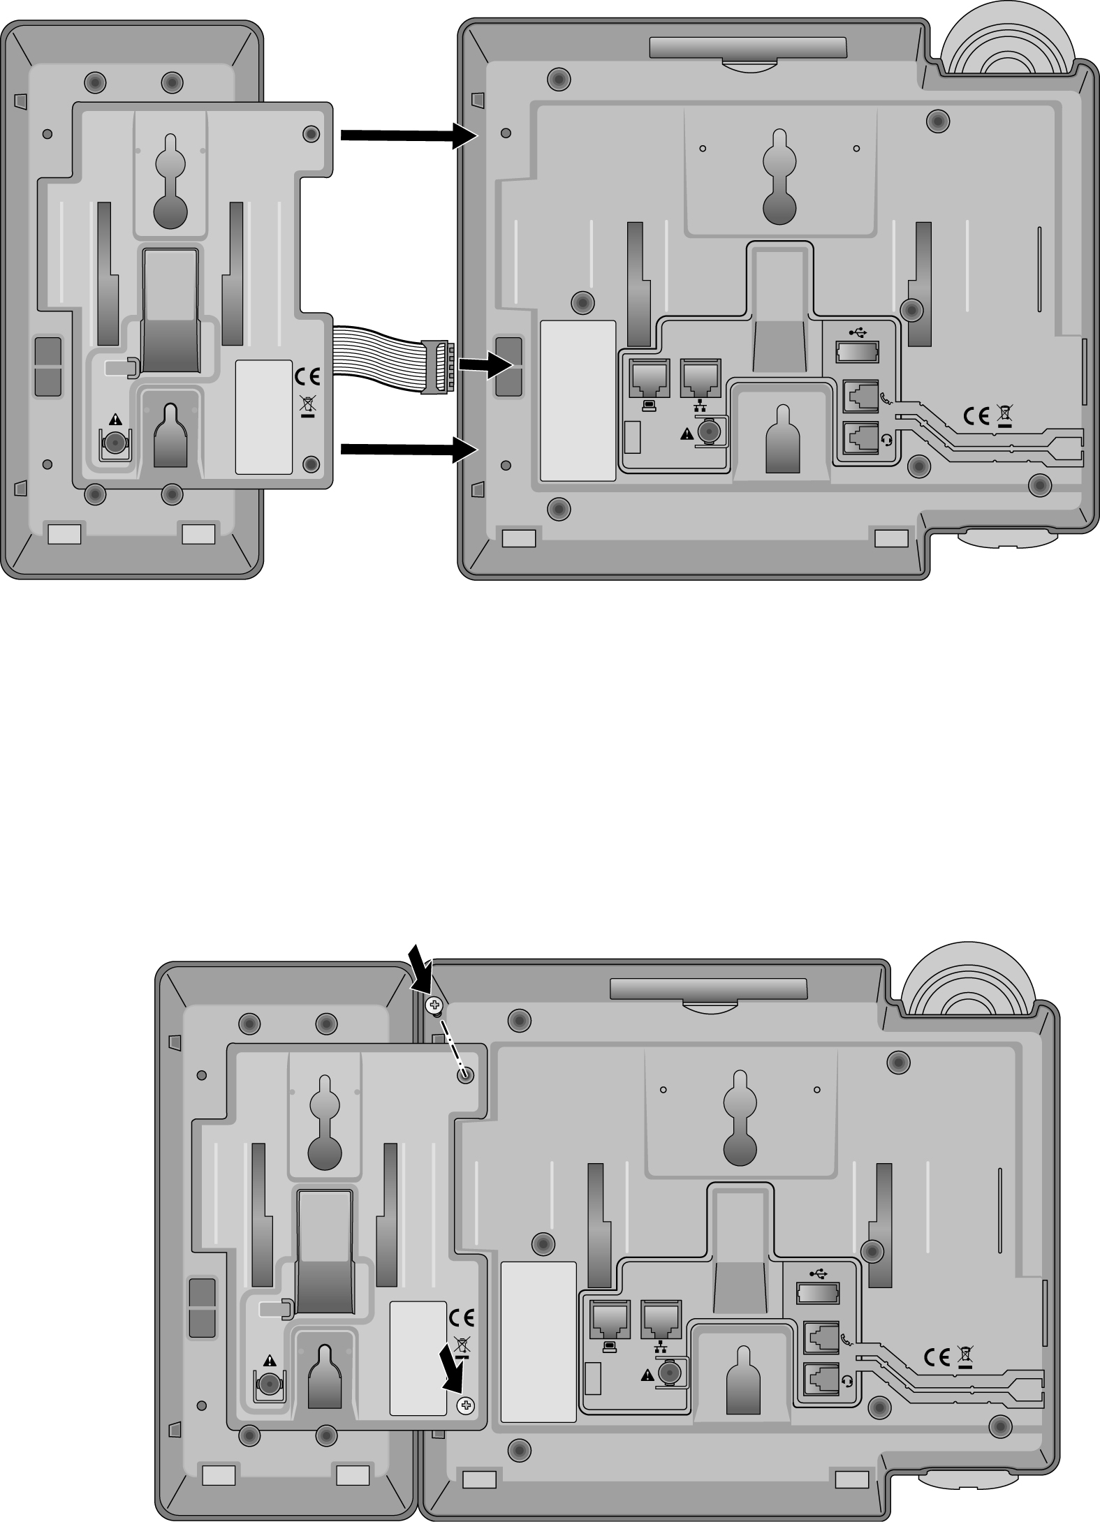
NOTE—LIP-8000 series consoles are powered through the flat cable used to connect the console to the IP phone (shown). Up to 2(without LIP-8048DSS) or 4(with LIP-8048DSS) consoles can be chain-link connected to the phone. DSS Connection to IP Phone

Wall Mount
The LIP-8000 series phones can be wall mounted as needed. The following instructions describe how to perform a wall mount installation. For more detailed instruction, refer to the iPECS Hardware Description and Installation Manual.
- Mark and drill two (2) 7mm holes for plastic wall anchors.
- Insert the two (2) anchors into the holes and insert and tighten the each screw leaving about 2.5 mm (1/8-inch) of the screw exposed.
- Slide the LIP-8000 phone over the screws and assure the phone is secure.
- NOTE—It may be necessary to remove the phone and tighten or loosen the screws for a secure mounting.

- Mark and drill two (2) 7mm holes for plastic wall anchors.
- Insert the two (2) anchors into the holes and insert and tighten the each screw leaving about 2.5 mm (1/8-inch) of the screw exposed.
- Slide the LIP-8000 phone over the screws and assure the phone is secure.
- NOTE—It may be necessary to remove the phone and tighten or loosen the screws for a secure mounting.

LCD, Speakerphone & Related Features
2. LCD, Speakerphone & Related Features

Using the LCD
The iPECS LIP-8040L has a large 9-line, 24 character across Liquid Crystal Display (LCD) which is divided into 3 sections. The upper section consists of 3 lines. The first line displays various icons. The 2nd and 3rd line are used to convey information to you. They provide the date, time and station number display while idle. It will also provide called/calling name/number display, feature status, etc.
The middle section displays the string of flex button or a monthly calendar. The user can select by pressing CALENDR Soft button of next page in idle state.
The lower section, which consists of a single line, is an interactive menu to guide you through feature access and User Program selections. The Navigation button is used to move through Display Menu items.
STATION 1003 (T)
JUL 31 06 12:41 pm
CO 001  CO 002  CO 003  CO 004  CO 005 | CO 006  CO 007  CO 008  CO 009  CO 010
FWD DIR LOG▶

Display Menu
With the Display Menu, you can access the Network Configuration menu as well as other phone features through simple menu trees. The Display Menu is activated using the Menu button.

In iPECS-LIK
To activate the Display Menu:
- Press Menu button,
- Press the Navigation up/down buttons and press the OK Soft button to select,
OR
- Dial the associated digit (Menu selections shown):
Select (0-4)

1. PHONE SETTING
2. CONFERENCE ROOM PGM
3. ICM SMS
4. Network Config
0. Attendant
BACK OK

NOTE—The ‘0. Attendant’ selection will only display on the System Attendant phone.

In iPECS-MG
To activate the Display Menu:
- Press Menu button,
- Press the Navigation up/down buttons and press the OK Soft button to select,
OR
- Dial the associated digit (Menu selections shown):
1. PHONE SETTING
2. NETWORK CONFIG

BACK OK EXIT

Phone Setting
In iPECS-LIK
To configure the Phone:
- Press Menu button and 1 (Phone Setting),
- The following menu displays:

Select (1-8)

1. STATION NAME PROGRAM
2. ICM RING
3. CO RING
4. PASSWORD PROGRAM 5. LANGUAGE PROGRAM
BACK OK

Select (1-8)

6. STA RING DOWNLOAD
7. BACKLIGHT
8. FONT PROGRAM

BACK OK
- Station Name Program—Input up to 12 digits using the keypad (press DND button to backspace/delete a character), then press the OK Soft button. To input characters:
  - Press the second Soft button to select ABC> or abc> mode,
  - To input the first character of a button, press the button 1 time (ex., for ‘a’, press 2 button once),
  - To input the second character of a button, press the button 2 times (ex., for ‘b’, press the 2 button twice.
  - To input the third character of a button, press the button 3 times (ex., for ‘f’, press the 3 button three times.
  - ICM Ring/CO Ring—Use Next Soft button to move through list of ring types, and press OK Soft button to select.

- Press Menu button and 1 (Phone Setting),
- The following menu displays:

Select (1-8)

1. STATION NAME PROGRAM
2. ICM RING
3. CO RING
4. PASSWORD PROGRAM 5. LANGUAGE PROGRAM
- BACK OK

Select (1-8)

6. STA RING DOWNLOAD
7. BACKLIGHT
8. FONT PROGRAM

- BACK OK
- Station Name Program—Input up to 12 digits using the keypad (press DND button to backspace/delete a character), then press the OK Soft button. To input characters:
- Press the second Soft button to select ABC> or abc> mode,
- To input the first character of a button, press the button 1 time (ex., for ‘a’, press 2 button once),
- To input the second character of a button, press the button 2 times (ex., for ‘b’, press the 2 button twice.
- To input the third character of a button, press the button 3 times (ex., for ‘f’, press the 3 button three times.
- ICM Ring/CO Ring—Use Next Soft button to move through list of ring types, and press OK Soft button to select.

- Password Program—Enter the current password and press the OK Soft button, then enter the new password and press the OK Soft button.
- Language Program—Use Navigation up/down buttons to highlight available languages supported, and press OK Soft button to select.
- Station Ring Download—Select the ring position (5-8) and select the ring file; press the SAVE Soft button to select.
- Backlight—Use Navigation up/down buttons to select the operation of the backlight, and press the OK Soft button to select.
- Font Program— Use Navigation up/down buttons to select the LCD Font, and press the OK Soft button to select.

In iPECS-MG
- Set Font Type—Select the font type(0 for new roman, 1 for gothic), and press the OK Soft button to select.
- Set Contrast—Press the VOL   buttons or Use Navigation up/down buttons to adjust the brightness, then press the OK Soft button to select.

Conference Room (iPECS-LIK)
The User can create and delete Conference rooms.
To configure a Conference Room:
- Press Menu button and 2 (Conference Room),
- The following menu displays:
SELECT (1-2)

1. CREATE CONF ROOM
2. DELETE CONF ROOM

- BACK OK
- Press the Navigation up/down keys to highlight and then press the OK Soft button to select,
OR
- Dial the number associated to the selection,
- Enter the room number and dial the password,
- Press the OK Soft button.

ICM SMS (iPECS-LIK)
The user can send SMS messages to other stations and retrieve received SMS messages.
To send a SMS message:
- Press Menu button and 3 (ICM SMS),
- The following menu displays:
SELECT (1-2)

1. SEND MESSAGE
2. IN BOX(03)

BACK OK
- Press the Navigation up/down keys to highlight and then press the OK Soft button to select,
OR
- Dial 1 to send a message,
- Dial 1 if resending, or 2 to send a new message (edit),
- Enter the Station number and message (if sending message),
- Press the OK Soft button.

To retrieve a SMS message:
- Press Menu button and 3 (ICM SMS),
- The following menu displays:
SELECT (1-2)

1. SEND MESSAGE
2. IN BOX(03)

BACK OK
- Press the Navigation up/down keys to highlight and then press the OK Soft button to select,
OR
- Dial 2 to retrieve a message.
- Dial 1 to send a message,
- Dial 1 if resending, or 2 to send a new message (edit),
- Enter the Station number and message (if sending message),
- Press the OK Soft button.

Network Config
The User can review the current network configuration or modify a new phone network configuration.
To access Network Config. settings:
- Press Menu button and 4 (Network Config),
- Enter the password (default=147*); the following will display:
MFIM #[1/2] ?
MFIM #1 - CHANGE[#]

- Press the # key to toggle between multiple profiles (MFIM),
- Press the VOL   buttons to advance to the next network configuration item,
- Press the Hold/Save button to save each setting.

To set default Config. settings:
- In Network Config. Menu, use VOL   buttons to locate the Default Config. Screen (shown),
SET DEFAULT CONFIG(DOT:*)

- Press the * key.
To exit Config. settings:
- Press the Speaker button,
- Press the * key to exit,
OR
- Press the # key to Reset/Reboot the phone with new setting.

Attendant menu (iPECS-LIK)
The Attendant menu is only available on the System Attendant phone.
- Set ICM Only Mode—Dial the Station Range for ICM only calls (ex., 103-108=103108), and press the OK Soft button.
- Restore COS—Dial the Station Range for COS restoring (ex., 103-108=103108), and press the OK Soft button.
- Monitor Conference Room—Enter the Conference Room number to view the number of attendees in the Conference Room.
- Delete Conference Room—Enter the Conference Room number and press the OK Soft button to delete.

Using the Speakerphone
Activate the iPECS Speakerphone at any time (except for Paging) in place of lifting the handset to receive or place calls.
To access the Attendant menu:
- From the Attendant Station phone, press the Menu button,
- Press 0 (Attendant); the following will display:
SELECT (1 - 5)
1. DATE/TIME SET
2. SET ICM ONLY MODE
3. RESTORE COS
4. MONITOR CONF ROOM
5. DELETE CONF ROOM
BACK OK

- Date/Time Set—Enter mm/dd/yy, and press OK Soft button; enter hh/mm, and press OK Soft button.

Additionally, you may switch between the handset and Speakerphone during a call. By keeping the handset Off-hook, the Group Listen feature is activated, which provides incoming audio over the speaker with outgoing audio from the handset. This permits a local ‘group’ to listen to both sides of the conversation without interfering with the conversation.
While in a conversation using the Speakerphone, Mute the microphone using the Mute button. When Mute is active, the Mute button LED will be illuminated. To turn off Mute, press the Mute button again.
With Auto Speaker Select, activating or accessing a feature by pressing its button will activate the Speakerphone automatically.
When using a Headset, the speaker button controls the ON/OFF-hook state for the phone.
To use the Speakerphone to answer or place a call:
- Press speaker, the phone goes off-hook and sends audio to the speaker and the microphone.
To control the volume of the Speakerphone or handset:
- Press the VOL▲ VOL▼ button.
To Mute the microphone:
- Select the Mute button.
To turn off Mute (turn the microphone ON):
- Press the Mute button.
To activate Group Listen while on an active handset call:
- Press the speaker button.

Using a Bluetooth Wireless Headset
The iPECS LIP-8040L may be equipped with a Bluetooth Unit (BTU) allowing you to use a wireless headset that supports Bluetooth version 2.0. Using a headset permits you to move freely around the phone (within approximately 10 meters) and maintain a conversation. Before using the headset, the headset must be “paired” with the BTU, and then the headset must be enabled for use. Operation of the iPECS LIP-8040L with the headset is the same as with the Speakerphone; press the Speaker button to activate the BTU to go ON and OFF-hook.
NOTE—during the pairing operation, the headset and phone should be as close as possible but not more than 1 meter apart.
To pair the wireless headset to the BTU:
- Press the Headset button,
- Dial 3(iPECS-LIK)/2(iPECS-MG),
- Press the hold/save button.
To enable/disable the wireless headset:
- Set the Bluetooth headset to pairing mode,
- Press the trans/pgm button,
- Dial *8(iPECS-LIK)/63(iPECS-MG),
- Dial 1 (enable),
- Press the hold/save button,
- Press the Next soft button, to select the headset,
- Press the OK soft button,
- Enter the PIN code referring to the Bluetooth headset manual (default=0000),
- Press OK Soft button.
NOTE—When the BTU is used for a call, the Speaker button LED will illuminate and the speaker mode cannot be used. If the phone handset is taken off-hook while in BT mode, the voice path will directly be connected to the handset; press the Speaker button to activate the BTU headset.
To unpair the headset:
- Press the trans/pgm button.
- Dial 3.
- Press the hold/save button.
To check Bluetooth paired information:
- Press the trans/pgm button.
- Dial *8.
- Dial 3.
- Press the OK Soft button.

To use a Serial DSS:
- Verify that the Station has Serial DSS usage authorization from Admin PGM111-Flex21.
- Verify that the Serial DSS power is OFF (LIP8048DSS only).
- Turn OFF the LIP 8016 or 8024 phone.
- Connect the Serial DSS to the phone by removing the RS-232 cable plug, and inserting RS-232 cable.
- Power-on the phone and the DSS (LIP-8048DSS only).
- Program the DSS button in Station Programming by pressing [PGM] + Flex button, or program DSS button using web Admin. Flexible button programming menu (Admin PGM 115).
- Edit LSS label from Admin PGM 129 (as needed). Otherwise, the default label is provided by the MFIM.
To initialize the Serial DSS database:
- Enter Admin. PGM 111-Flex21.
- Select the Station range to clear Serial DSS Database.
- Dial 0.
- Press the hold/save button.
To unpair the BTU headset:
- Set the Bluetooth headset to pairing mode,
- Press the trans/pgm button,
- Dial *8(iPECS-LIK)/63(iPECS-MG),
- Dial 2 (disable),
- Press the OK soft button.
To check BTU paired information:
- Press the trans/pgm button,
- Dial *8(iPECS-LIK)/63(iPECS-MG),
- Dial 3,
- Press the OK soft button.
To use the BTU headset:
- Press the Speaker button,
OR
- Press the Call Start button on the BTU headset,
- Place call as you normally would.
To answer a call with the BTU headset:
- When an incoming call is received, ringing will be present at the Station and the BT headset,
- Press the BT Call Start button, or press the Speaker button,
OR
- Lift the handset.

Using a Serial DSS
The LIP-8012DSS, LIP-8012LSS, and LIP-8048DSS can be connected with the LIP-8040L using the RS-232 cable. Be sure to verify the serial DSS and LSS capacities with the iPECS System to ensure usability (refer to iPECS Manual). The following graphics show the front and rear view of each.
NOTE—A Linked Pair slave station cannot use a serial DSS.

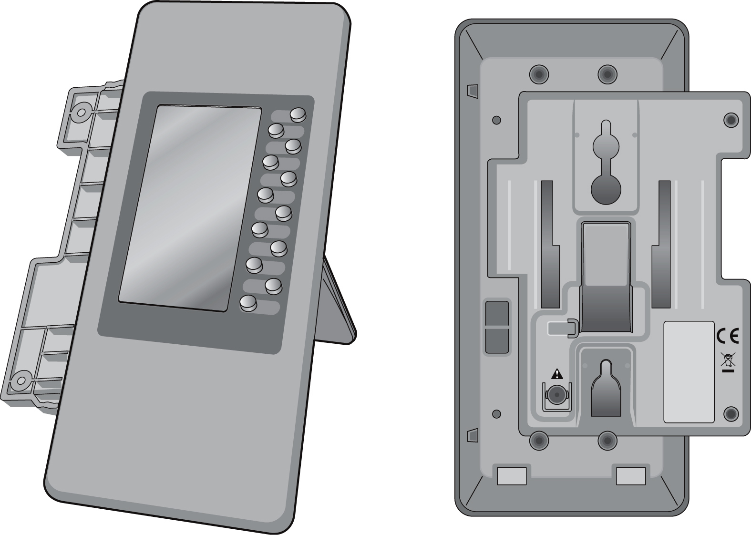
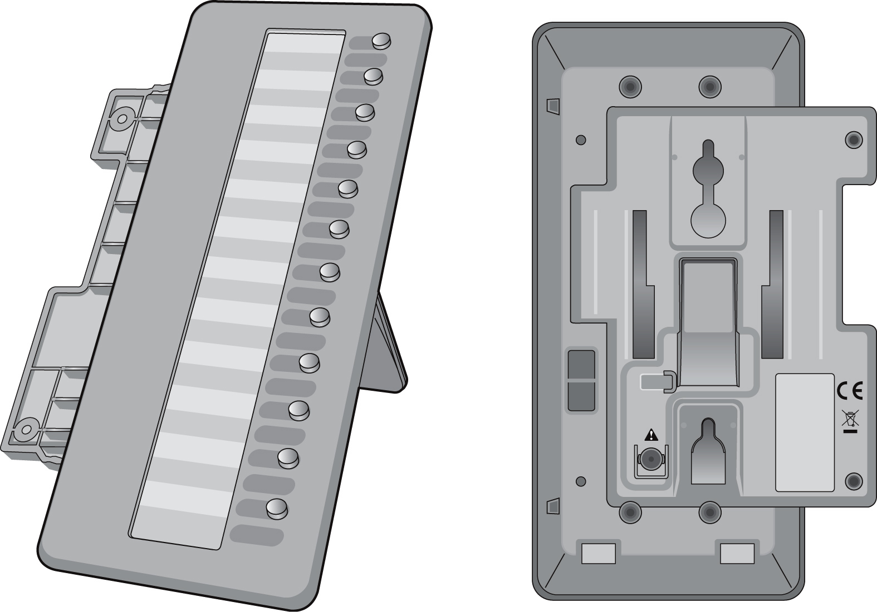
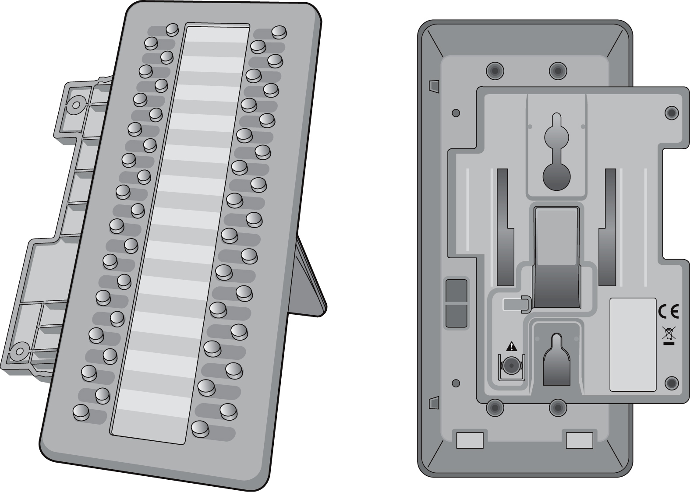
LIP-8012DSS
LIP-8012LDSS

LIP-7016D & 7024D

To assign a feature to a Flex button:
Press trans/pgm,
Press the desired Flex button,
Dial desired code and required inputs; for User Program codes Appendix B), first press the trans/pgm,
Press hold/save.

LIP-7016D & 7024D

To assign a feature to a Flex button:
Press trans/pgm,
Press the desired Flex button,
Dial desired code and required inputs; for User Program codes Appendix B), first press the trans/pgm,
Press hold/save.

LIP-7016D & 7024D

To assign a feature to a Flex button:
Press trans/pgm,
Press the desired Flex button,
Dial desired code and required inputs; for User Program codes Appendix B), first press the trans/pgm,
Press hold/save.

LIP-7016D & 7024D

To assign a feature to a Flex button:
Press trans/pgm,
Press the desired Flex button,
Dial desired code and required inputs; for User Program codes Appendix B), first press the trans/pgm,
Press hold/save.

LIP-8048DSS

In iPECS-LIK
To use a Serial DSS:
- Verify the Station has Serial DSS Usage authority (Admin PGM111-Flex21),
- Verify the DSS power is OFF (LIP-8048DSS only),
- Power-OFF the phone,
- Connect the serial DSS to the phone,
- Power-ON the phone and the DSS (LIP-8048DSS only),
- Program the DSS button using Web Admin Programming or PGM115,
- Edit LSS label from Admin PGM129 (default label is provided from MFIM).
To initialize Serial DSS Database:
- Enter Admin PGM111-Flex21,
- Select Station range to clear Serial DSS Database,
- Dial 0, and press the Hold/Save button.
In iPECS-MG
To use a Serial DSS:
- Set the Station’s Serial DSS Usage Map (Admin PGM120-Flex2),
- Verify the DSS power is OFF (LIP-8048DSS only),
- Power-OFF the phone,
- Connect the serial DSS to the phone,
- Power-ON the phone and the DSS (LIP-8048DSS only),
- Program the DSS button using Web Admin Programming or PGM126,
- Edit LSS label from Admin PGM126.
To initialize Serial DSS Database:
- Clear the Station’s Serial DSS Usage Map (Admin PGM120-Flex2),
- Admin PGM120-Felx3 to reset the phone.

3. Receiving Calls

Receiving calls

Answering a Call While Idle
There are 3 basic types of incoming calls; internal/external ringing calls, Intercom Voice Announce calls, and Hold recalls.
Your phone may be assigned Ringing Line Preference; in this case, calls that ring are answered by lifting the handset. Otherwise, you must press the flashing Flex button.
External calls to an iPECS Phone will appear under the CO/IP line or a LOOP button.
External calls are from CO lines or VoIP channels that are programmed to ring at your phone. For external calls, Delay Ring may be assigned allowing others to answer the call before the call rings at your phone.
Calls can be forwarded in some manner from another user; if providing call coverage for other users, you may also receive Station Call Coverage calls.
Calls placed on Hold, including Transfers, parked calls, etc. will recall if left on hold for too long.
ICM Voice Announce calls are answered based on the ICM Signaling mode at the receiving phone; in Hands-free (HF) mode, after the splash tone and announcement, speak normally into the microphone. In the Privacy (PV) mode, lift the handset to respond. The ICM Signaling mode can be assigned in Station Programming.
The LCD will display the calling number or, if available, the name of the station or CO/VoIP line, CO Line Name Display.
To answer a call ringing at your phone:
- Lift the handset or press the flashing Flex button (as needed), the call will be connected.
To respond to an Intercom Voice Announce call:
- In HF mode, simply speak as normal into the microphone,
OR
- In PV mode, lift the handset to respond.

Responding to a Call While Busy
While you are busy on another call, you may receive a Muted Ring, Camp-On tones, or Voice-Over announcements. Muted Ring is provided over the speaker of your Phone indicating a Call Waiting. You also may receive Camp On tones, a burst of tones on top of the existing call, as an indication of another call waiting.
While busy, certain stations can activate Voice-Over to your phone. In this case, audio is received from both the active call and the Voice Over announcement at the same time.
Respond to any of these Off-hook Signals in one of several ways; place the existing call on Hold and respond to the new incoming call, activate One-time DND, send a Silent Text Message, or ignore the new call.
Silent Text Message requires a text message button (not available on a SLT or other non-display terminal).
The Attendant or Secretary may use Intrusion to announce a call while you are busy.
To answer a Call Waiting:
- Press hold/save, and/or
- Press the flashing co/ip line button.
To activate One-time DND:
- Press the DND button.
To send a Silent Text Message:
- Press the programmed text message button,
- Select the desired message to send.

Using Answering Machine Emulation (AME)
When a call is connected to your voice mail, you can screen the call as if using a normal Answering Machine. The caller’s voice is played over your speaker while the message is being recorded. There are two methods of notification and call screening provided, Ring or Speaker mode.
Ring mode(iPECS-Lik)/LED Blink Mode(iPECS-MG)—the Answering Machine Emulation (AME) Flex button will flash to notify you of a call. You may press the Flex button to hear the caller as the voice message is stored.
Speaker mode(iPECS-Lik)/Speaker Hearing Mode(iPECS-MG)—when the call is sent to the voice mailbox, the caller’s voice is automatically broadcast over the speaker of your iPECS Phone.
You may terminate screening, leaving the caller in voice mail to record a message, talk with the caller and record the conversation in the mailbox, or answer the call and disconnect the Voicemail. The AME feature is only available when using the iPECS VMIM/VSF Voice Mail; a Mute and AME button should be programmed (refer to Appendix A User Program Codes).
To screen a call in Ring mode(iPECS-LIK)/LED blink mode(iPECS-MG):
- Press the flashing ame button, the caller’s voice is broadcast over the station speaker and stored in the voice mailbox (in the Speaker mode, broadcast is automatic).
To stop the voice broadcast and leave the caller in Voice Mail:
- Press the illuminated speaker button.
To talk with the caller and record the conversation in Voice Mail:
- Press the mute button.
To answer the call and cancel the voice message recording:
- Press the illuminated ame button, the caller is connected and the Voice Mail disconnected.

Differential Ring Signals
When multiple phones in a small area ring, it can be difficult to tell which are ringing. The iPECS Phone has 14 Ring Tones available for differentiating one phone’s ringing from another. Four of the tones are stored in the phone permanent memory; the remaining ten tones are in the system memory. Four of these ten can be downloaded into the phone memory for use as the 5th to 8th Ring Tone.

In iPECS-LIK
To download a Ring Tone from System memory:
- Press trans/pgm,
- Dial 1 for Ring Tones,
- Dial 5 for Ring Tone download,
- Dial the phone’s memory location to receive the tone (5-8),
- Dial 0-9 for the desired tone number; a confirmation tone is heard,
- Press hold/save to download.
To select a Ring Tone from phone memory:
- Press the trans/pgm button,
- Dial 1 for Ring Tones,
- Dial 1 or 2 for Internal or External ring,
- Dial 1-8 for the desired tone number; a confirmation tone is heard,
- Press hold/save to make the selection.
In iPECS-MG
To download a Ring Tone from System memory:
- Press trans/pgm,
- Dial 2 for Ring Tones,
- Dial 3 for Ring Tone download,
- Dial the phone’s memory location to receive the tone (5-8),
- Dial 0-9 for the desired tone number; a confirmation tone is heard,
- Press hold/save to download.
To select a Ring Tone from phone memory:
- Press the trans/pgm button,
- Dial 2 for Ring Tones,
- Dial 1 or 2 for Internal or External ring,
- Dial 1 for Keyset Ring Source,
- Dial 1-8 for the desired tone number; a confirmation tone is heard,
- Press hold/save to make the selection.

Answering Calls at Night
In the Night mode, Loud Bell Control may be used to send ring signals to external bells. You may answer these calls with Universal Night Answer (UNA).
To answer a call ringing during night mode:
- Lift the handset,
- Dial 567 (iPECS-Lik)/ 587(iPECS-MG) (UNA code).

Answering Calls to Other Stations
When nearby stations are ringing, you may pick-up (answer) the call. Select to answer a call ringing at a specific station (Directed Call Pick-Up) or you may choose to answer the oldest call ringing to your station group (Group Call Pick-Up). Assign a Flex button with the Group Call Pick-Up code (566) for one-touch access.
NOTE—Pick-Up will not answer calls on the ringing station Private Line unless the line appears on your phone.
To answer a call ringing at another station:
- Lift the handset,
- Dial 7 (Directed Call Pick-Up code),
- Dial the Intercom Number of the ringing station; the call will be connected.
To answer a call ringing at a station in your group:
- Lift the handset,
- Dial 566 (Group Call Pick-Up code), the call is connected.

Using Do-Not-Disturb (DND) to Block Incoming Calls
Activate Do-Not-Disturb when you wish to not be interrupted; the phone will block incoming calls. Internal callers will receive a fast busy tone and the display will show the DND status. Activate Do-Not-Disturb while ringing(One-Time DND); Ringing terminates and the caller will get a fast busy tone and it requires a DND button.
When an Executive activates DND, calls are forwarded to the paired Secretary automatically.
The Attendants and Secretary may be able to activate DND Override and Intrude on an active call. The Attendants may also cancel DND at other stations.
To toggle DND ON and OFF:
- Press the DND button.

Forwarding Calls

Forwarding calls to another Station or Voice Mail
Incoming calls may be diverted to other resources of the system. Resources include other stations, VMIM/VSF Voice Mail and External Voice Mail. Your LCD and the LCD of the forward receiver will both indicate the forward status.
Call Forward can be activated from your phone or from a different station (Call Forward, Remote). You may define the conditions or ‘type of forward’ as below:
1: Unconditional—all calls to the station, except recalls, are forwarded.
2: Busy—Immediately forwards all calls, except recalls, when the station is busy.
3: No Answer—forwards all calls to the station, except recalls, when the station does not answer within the No Answer timer.
4: Busy/No Answer—forwards calls if the station is busy or does not answer within the No Answer timer.
When you forward calls from a different station, you may need to enter your Authorization Code.
Calls on a Private Line will not forward except to a station with an appearance of the Private Line or to Voice Mail.
To activate Call Forward from your phone to another phone or internal system resource:
- Lift the handset,
- Press the Fwd Soft button,
- Dial the type of forward code 1-4,
- Dial the destination number.
To deactivate Call Forward from your phone:
- Press the Fwd Soft button,
- Dial #.
To activate Call Forward for your phone from a different phone within the System (Call Forward, Remote):
- Lift the handset,
- Press the Fwd Soft button,
- Dial 0 (Remote Call Forward code),
- Dial your Authorization code (Station number & Password),
- Dial the ‘type of forward’ code 1-4,
- Dial the destination number.
To deactivate Call Forward, Remote:
- Lift the handset,
- Press the Fwd Soft button,
- Dial 0 (Remote Call Forward code),
- Dial your Authorization code (Station number & Password),
- Press the # key.

Forwarding calls to an external number
Forward calls to an external destination; calls can be forwarded from an internal station or a remote location. You may define the conditions or ‘type of forward’ as listed below:
1: Unconditional—all calls to the station, except recalls, are forwarded.
2: Busy—Immediately forwards all calls to the station, except recalls, when station is busy.
3: No Answer—forwards all calls to the station, except recalls, when the station does not answer within the No Answer timer.
4: Busy/No Answer—forwards calls if the station is busy or does not answer within the No Answer timer.
When you forward calls from a different station or a remote location, enter your Authorization Code. In addition, from a remote location, you must access the system through a DISA enabled CO line.
In iPECS-LIK
To activate Call Forward, Off Premise (forward to an external number) from your phone:
- Lift the handset,
- Press the Fwd Soft button,
- Dial the type of Forward code (1-4),
- Press Speed Soft button,
- Dial Speed Dial bin number,
- Replace the handset, return to idle.
To activate Call Forward, Off Premise (forward to an external number) from a different phone within the System:
- Lift the handset,
- Press the Fwd Soft button,
- Dial 0 (Remote Call Forward code),
- Dial your Authorization code (your Station number + Password),
- Dial the type of Forward code (1-4),
- Press Speed Soft button,
- Dial Speed Dial bin number,
- Replace the handset, return to idle.
To activate Call Forward, Off Premise (forward to an external number) from a remote location:
- Lift the handset,
- Dial the telephone number of a DISA assigned CO line,
- While receiving dial-tone, dial 554 (Call Forward feature code),
- Dial your Authorization Code (your Station number + Password),
- Dial the type of Forward code (6-9),
- Dial Speed Dial bin number,
- Replace the handset, return to idle.

In iPECS-MG
To activate Call Forward, Off Premise (forward to an external number) from your phone:
- Lift the handset,
- Press the Fwd Soft button or dial 554
- Dial the type of Forward code (1-4),
- Dial Telephone number,
- Replace the handset, return to idle.
To activate Call Forward, Off Premise (forward to an external number) from a different phone:
- Lift the handset,
- Press the Fwd Soft button or dial 554,
- Dial 0 (Remote Call Forward code),
- Dial your Authorization code (your Station number + Password),
- Dial the type of Forward code (1-4),
- Dial Telephone number,
- Replace the handset, return to idle.

Forwarding callers to a Text Message
Using an iPECS Phone, the system can be setup to return a ‘Text Message’ to internal callers. When calling your Station, internal callers will automatically receive the selected message or you can send a text message you select in response to an internal call, Silent Text Message.
There are 11 Custom Display Messages each up to 24 characters. Ten can be assigned by the Attendant and one assigned by you.
In addition, there are ten fix Pre-Defined Text Messages; some allow auxiliary input for time, date, etc. (as shown in message list).

In iPECS-LIK
Message 01: LUNCH RETURN AT hh:mm
Message 02: ON VACATION
RETURN AT DATE mm:dd
Message 03: OUT OF OFFICE
RETURN AT TIME hh:mm
Message 04: OUT OF OFFICE
RETURN AT DATE mm:dd
Message 05: OUT OF OFFICE
RETURN UNKNOWN
Message 06: CALL (enter up to 17 digits)
Message 07: IN OFFICE STA xxxx
Message 08: IN MEETING
RETURN AT TIME hh:mm
Message 09: AT HOME
Message 10: AT BRANCH OFFICE

In iPECS-MG
Message 1: LUNCH RETURN AT hh:mm
Message 2: ON VACATION
RETURN AT DATE mm:dd
Message 3: OUT OF OFFICE
RETURN AT TIME hh:mm
Message 4: OUT OF OFFICE
RETURN AT DATE mm:dd
Message 5: OUT OF OFFICE
RETURN UNKNOWN
Message 6: CALL (enter up to 17 digits)
Message 7: IN OFFICE STA xxxx
Message 8: IN MEETING
RETURN AT TIME hh:mm
Message 9: AT HOME
Message 0: AT BRANCH OFFICE
* User Custom Message
# Deactive

In iPECS-LIK
To activate Custom or Pre-Defined Message Forward:
- Press trans/pgm,
- Dial User Program feature code 51,
- Dial the two-digit text Message code (00-20),
- Dial any auxiliary input for messages 01-04 and 06-08,
- Press hold/save, forward confirmed.
To cancel activated Message:
- Press the Fwd Soft button,
- Dial #.
To program the Station Custom Message (00) at your station:
- Press trans/pgm,
- Dial User Program feature code 52,
- Enter Message contents, up to 24 characters, using the following Character Entry Chart:

Q – 11  Z – 12  . – 13  1 – 10 | A - 21  B - 22  C - 23  2 - 20 | D - 31  E - 32  F - 33  3 - 30
G – 41  H - 42  I - 43  4 - 40 | J - 51  K - 52  L - 53  5 - 50 | M - 61  N - 62  O - 63  6 - 60
P - 71  R - 72  S - 73  Q - 7*  7 - 70 | T - 81  U - 82  V - 83  8 - 80 | W - 91  X - 92  Y - 93  Z - 9#  9 - 90
*1 - Blank  *2 - :  *3 - , | 0-00 | #
Character Entry Chart

- Press hold/save, to save the message.
In iPECS-MG
To activate Custom or Pre-Defined Message Forward:
- Press trans/pgm,
- Dial User Program feature code 41,
- Dial the one-digit text Message code (0-9),
- Dial any auxiliary input for messages 1-4 and 6-8,
- Press hold/save, forward confirmed.
To cancel activated Message:
- Press the Fwd Soft button,
- Press fwd button or dial 554,
- Dial #.
To program the Station Custom Message (00) at your station:
- Press trans/pgm,
- Dial User Program feature code 42,
- Enter Message contents, up to 24 characters, using the following Character Entry Chart:
Dial Pad button | Letter Type
Dial Pad button | Uppercase  (ABC) |  |  |  | Lowercase  (ABC) |  |  |  | Num
Dial Pad button | Button depressions
Dial Pad button | 1 | 2 | 3 | 4 | 1 | 2 | 3 | 4 | 1
1 | @ | : | / | < | @ | : | / | < | 1
2 | A | B | C |  | a | b | c |  | 2
3 | D | E | F |  | d | e | f |  | 3
4 | G | H | I |  | g | h | i |  | 4
5 | J | K | L |  | j | k | l |  | 5
6 | M | N | O |  | m | n | o |  | 6
7 | P | Q | R | S | p | q | r | s | 7
8 | T | U | V |  | t | u | v |  | 8
9 | W | X | Y | Z | w | x | y | z | 9
0 | . | , | ? | ! | . | , | ? | ! | 0
* | * |  |  |  | * |  |  |  | *
# | # |  |  |  | # |  |  |  | #
Character Entry Chart

- Press hold/save, to save the message.
4. Placing Calls

Placing a call

Internal Calls
You can place calls to other stations in the system over the Intercom. The call will ring, or for an ICM Voice Announce call, a splash tone will be heard. Ring or Voice Announce is normally determined by settings at the called station but you may change this by dialing ‘#’ after placing the call. By changing the mode, a Voice Announce call will ring or a ringing ICM call will allow Voice Announce (toggle).
You can assign a Flex button for Direct Station Selection/Busy Lamp Field (DSS/BLF). The dss/blf button allows you to call another station with the single touch of a button. The button LED will display the other station’s status (ON=busy, OFF=idle).
When you go off-hook, you may connect to another station or system resource automatically. This Prime Line Preference may be immediate or delayed allowing you to take other actions during the delay. Otherwise, you may press another Flex button before going off-hook to override Prime Line Preference.
If you go off-hook and take no action, Intercom dial-tone will time-out, and after the Howler tone is received, your phone will be placed out-of-service in Intercom Lock-Out; you then must hang-up to return the phone to an idle state.
To place an Intercom call:
- Lift the handset,
- Dial the Intercom number of the desired station,
- When the call is answered or the Splash tone is heard, begin speaking with the called party.

Using Camp-On when calling a busy station
If the called party is busy, you may activate Camp-On, Callback or Voice Over at the station. Camp-On allows you to wait off-hook for the called station to answer. Callback allows you to hang-up, and when the busy station returns to an idle state, the system will call your Station; after you answer the callback, the system will call the previously busy station.
If you are the Attendant or Secretary, you may activate Intrusion. You may also use Step Call; dial the next station by dialing the last digit of the Intercom number.
To Camp-On (wait off-hook) for a busy station:
- Press * and await an answer.
To request a Callback (wait on-hook) for a busy station:
- Press the MSG button and hang-up.
To make a Voice Over announcement to a busy station:
- Dial #,
- After the Splash tone is heard, begin speaking.

Leaving a Message Wait
If the called user does not answer or is in DND mode, you may leave a Message Wait. The called user will receive a Message Wait indication; the message icon will be displayed. If the ring/message LED is set to Message Wait Indication, the ring/message LED will flash.
To activate Message Waiting:
- When calling a number that is busy or in DND mode, press the MSG button and hang-up.

External Calls

Placing external CO/VoIP calls
External calls are placed on CO/IP lines. These ‘lines’ are accessed either using a button on the iPECS Phone assigned as a CO/IP line or using dial codes. The CO/IP lines are grouped for different types of calls, local, long distance, etc. Using the CO/IP line group code, you will be able to access any line from the group. A Flex button on the iPECS Phone assigned as a loop button lets you access a line from a group. Dial codes for access to CO/IP lines are:
Individual CO/IP line access—
88 + Line number (01-42 for iPECS-100, or 001-200 for iPECS-300 & 600).
or
88 + Line number (01-80 for iPECS-MG100, or 001-240 for iPECS-MG300).

CO/IP Group access—
801-820 for iPECS-100, or 801-872 for iPECS-300 & 600
or
801-824 for iPECS-MG100, or 801-872 for iPECS-MG300

Any CO/IP Line access—
9

When dialing on a CO line which uses pulse style signals, you may activate Dial Pulse to Tone Switchover changing to DTMF style dialing (for banking services, etc.).
When placing an IP call, you must dial an IP address using the ‘*’ key in place of the dot.
If Least Cost Routing is set-up, the number you dial will be analyzed and the system will place the call on the least expensive route.
You may be assigned Dialing and/or CO/IP Line Access Restrictions, in which case you will receive error tone if you attempt to dial or access a restricted number/CO/IP line. CO/IP line and Station Class Of Service (COS), which establish dialing restrictions, may vary during Day and Night operation (Day/Night COS).
You may need to enter an Authorization code before placing calls, in which case you will receive a second dial tone.
Your external calls may be subject to Call Time Restrictions, you will receive a Call Warning Tone prior to disconnect.
NOTE—In the event of an emergency, assigned Emergency numbers (ex., a 911 call) may be dialed from any station in the System, regardless of a Station’s dialing restrictions (COS).
To place an external call:
- Lift the handset,
- Dial the CO/IP line/group,
- Dial the desired number.

Waiting for the next available CO/IP line
If all the lines connected to your system are busy, you will receive an All Trunks Busy signal. You may request to be notified when a line is available for use.
To activate a queue if the selected/dialed line is busy:
- Select the desired CO/IP line button; when the busy notification is returned, press the MSG button,
- Return to an idle state by going on-hook; when the line is available, the Station will be notified (ringing).

Account Codes: Tracking External calls for billing
In some cases, you or your company may desire to track calls for billing or other purposes. You may enter an Account Code, which is output from the system to a printer in the SMDR report. You may have an Account Code Flex button (refer to Assigning features to Flex buttons).
To enter an Account Code before the call:
- Lift the handset,
- Press the assigned account code button,
- Dial the Account Code (1-12 digits),
- Press *, Intercom dial tone is heard,
- Place the CO/IP call as normal.
To enter an Account Code during a call:
- Press the assigned account code button,
- Dial the Account Code (1-12 digits),
- Press *.

Disable dialing from your phone
You can temporarily ‘Lock’ your phone by activating Temporary COS, which will disable all dialing from the phone. To deactivate Temporary COS you must enter the station’s Authorization code.
To activate Temporary COS:
- Press trans/pgm,
- Dial 21(iPECS-LIK)/31(iPECS-MG) (User Program code),
- Dial your Authorization code(iPECS-MG),
- Press hold/save.
To deactivate Temporary COS:
- Press trans/pgm,
- Dial 22(iPECS-LIK)/32(iPECS-MG) (User Program code),
- Dial your Authorization code,
- Press hold/save.

Temporarily override dialing restrictions at a phone
Override the dialing restrictions at any phone by activating Walking COS. The Walking COS dialing restriction levels are applied for a single call only. For multiple calls, you will need to reactivate Walking COS or use the Flash Soft button to regain CO/IP dial-tone.
To activate Walking COS:
- Press trans/pgm,
- Dial 23(iPECS-LIK)/33(iPECS-MG) (User Program code),
- Dial your Authorization Code (station number and password),
- Dial ‘*’ (iPECS-MG)
- Place call as normal.

Using Directory

Using Last Number Redial (LNR)
The last number dialed on an external call is automatically saved in the Last Number Redial (LNR) buffer. The iPECS Display Phone, the system will store the numbers dialed on the last 15(iPECS-LIK)/100(iPECS-MG) calls.
In iPECS-LIK
To dial the Last Number for an external call:
- Lift the handset, and/or press the DIR Soft button,
- Press Speed Soft button,
- Dial *,
- Press the Navigation up and down buttons to select from the last 15 numbers dialed,
- Press the Send Soft button or hold/save.
In iPECS-MG
To dial the Last Number for an external call:
- Lift the handset,
- Press Speed Soft button,
- Dial *,
- or
- press the LOG Soft button,
- Press the Navigation up and down buttons to select from the last 100 numbers dialed or received,
- Press the Send Soft button or hold/save.

Using and Entering Saved Number Dial
You may store the last number dialed on an external call to the Saved Number Dial buffer for convenient dialing at a later time. The Saved number is stored until a new number is saved.
To place a call using Save Number Dial:
- Lift the handset, and/or press the DIR Soft button,
- Press Speed Soft button(iPECS-LIK)/Dial 1 for Station Speed(iPECS-MG),
- Dial #.
To store a number in the Save Number Dial:
- While on an outgoing external call, press the Save Soft button.

Using System Speed Dial Numbers
The iPECS-100 system has memory allocated for 800 System Speed Dial numbers (bins 200-999). The iPECS-300 & 600 systems each have memory allocated for 3000 System Speed Dial numbers (bins 2000-4999).
The iPECS-MG100 system has memory allocated for 1000 System Speed Dial numbers (bins 2000-2999). The iPECS-MG300 system has memory allocated for 2000 System Speed Dial numbers (bins 2000-3999). You may, if allowed, use System Speed Dial to call frequently dialed numbers.
In some cases, these numbers are divided into groups called System Speed Zone Groups. In this case, you may access some numbers and not others and your dialing restrictions may be invoked.
Only an Attendant can assign System Speed Dial numbers.
To place a call using System Speed Dial:
- Lift the handset,
- Press the DIR Soft button,
- Press the speed button(iPECS-LIK)/Dial 2 for System Speed(iPECS-MG),
- Dial the desired System Speed Dial bin number (200-999 for iPECS-100 or 2000-4999 for iPECS-300 & 600) ,2000-2999 for iPECs-MG100 , or 2000-3999 for iPECS-MG300).

Using and Entering Station Speed Dial Numbers
Each station in the iPECS-100 System is allocated memory for 20 Station Speed Dial numbers (bins 00-19) each up to 48 digits. The iPECS-300 & 600 support 100 Station Speed Dial numbers (bins 000-099). The iPECS-MG 100 & 300 each support 50 Station Speed Dial numbers (bins 000-049). These numbers are entered at the user’s station and may include several ‘special’ instructions. Special instructions and the corresponding button are:
PAUSE will momentarily stop dialing.
FLASH as 1st digit—Activate dial tone detect.
FLASH not as 1st digit—The system will generate a flash on the CO line.
MSG as 1st digit—Send digits as ISDN Keypad Facility message.
‘*’ as 1st digit—Display Security, the stored number will not be displayed when used.
‘*’ not as 1st digit—Dial Pulse to Tone Switchover, the system will switch from pulse to tone dialing.
When entering a Speed Dial, a 16-character name may be associated with the number for Dial by Name. Characters are entered with two keystrokes as shown.

Q – 11  Z – 12  . – 13  1 – 10 | A - 21  B - 22  C - 23  2 - 20 | D - 31  E - 32  F - 33  3 - 30
G – 41  H - 42  I - 43  4 - 40 | J - 51  K - 52  L - 53  5 - 50 | M - 61  N - 62  O - 63  6 - 60
P - 71  R - 72  S - 73  Q - 7*  7 - 70 | T - 81  U - 82  V - 83  8 - 80 | W - 91  X - 92  Y - 93  Z - 9#  9 - 90
*1 - Blank  *2 - :  *3 - , | 0-00 | #
Character Entry Chart(iPECS-LIK)

Dial Pad button | Letter Type
Dial Pad button | Uppercase  (ABC) |  |  |  | Lowercase  (ABC) |  |  |  | Num
Dial Pad button | Button depressions
Dial Pad button | 1 | 2 | 3 | 4 | 1 | 2 | 3 | 4 | 1
1 | @ | : | / | < | @ | : | / | < | 1
2 | A | B | C |  | a | b | c |  | 2
3 | D | E | F |  | d | e | f |  | 3
4 | G | H | I |  | g | h | i |  | 4
5 | J | K | L |  | j | k | l |  | 5
6 | M | N | O |  | m | n | o |  | 6
7 | P | Q | R | S | p | q | r | s | 7
8 | T | U | V |  | t | u | v |  | 8
9 | W | X | Y | Z | w | x | y | z | 9
0 | . | , | ? | ! | . | , | ? | ! | 0
* | * |  |  |  | * |  |  |  | *
# | # |  |  |  | # |  |  |  | #
Character Entry Chart(iPECS-MG)

To place a call using Station Speed Dial:
- Lift the handset, and/or press the DIR Soft button,
- Press the Speed Soft button(iPECS-LIK)/Dial ‘1’ for station speed(iPECS-MG),
- Dial the desired Station Speed Dial bin number (00-19 or 000-099 or 000-049).
To enter a Station Speed Dial number with CO Line and Name:
- Lift the handset, and/or press the DIR Soft button,
- Press the Speed Soft button(iPECS-LIK)/Dial ‘1’ for station speed(iPECS-MG),
- Press the ADD Soft button,
- Dial the desired Station Speed Dial bin number,
- Select/dial the CO/IP line/group,
- Dial the desired number to be stored,
- Press hold/Save,
- Enter the associated name if desired, using the Character Entry Chart,
- Press hold/Save.
To assign a Station Speed Dial number directly to a Flex button:
- Press trans/pgm,
- Press the desired Flex button,
- Select the Tel Num Soft button(iPECS-LIK)/Dial ‘1’ for Number(iPECS-MG),
- Select/dial the CO/IP line/group,
- Dial the desired number,
- Press hold/Save,
- Enter the associated name if desired, using the Character Entry chart(iPECS-LIK),
- Press hold/Save.

Using Dial by Name and Entering Your Name
Dial by Name employs three different Directories: Private directory (Station Speed dial), Public Directory (System Speed dial), or Intercom directory.
NOTE—To allow others to contact you via the Intercom directory, you must enter a name for your station (up to 12 characters).
To place a call using Dial by Name:
- Press DIR Soft button,
- Dial the desired directory, 1: Private directory, 2: Public directory, 3: Intercom directory, the LCD will display the names in alphabetical order,
- Scroll using the Navigation up/down keys, or enter search characters (refer to the Character Entry Chart in Section 4.3.4).
- Press hold/save to place the call.
To enter your station user name:
- Press the trans/pgm button,
- Dial 74(iPECS-LIK)/12(iPECS-MG) (Station User Name code),
- Enter the Name, up to 12 characters (press DND button to backspace/delete a character):
- To input alphabet
1. Select ABC> or abc> mode by pressing 2nd Soft
Button,
2. To input 1st character in each dial button(2~9), press
the button, once,
To input 2nd character, press the button, twice,
To input 3rd character, press the button, three times,
(Ex., To input ‘K’, press the ‘5’ button, twice).
3. To input a character in the same button, continuously
press the button after 2 seconds.
(Ex., in case of KL, press the ‘5’ button twice, then
wait 2 seconds and press the ‘5’ button three times).
- Press hold/save.

Using Automatic Called Number Redial (ACNR)
When making an external call and a busy signal is received, the system can be set to retry the number until the call is connected, the feature is cancelled, or the maximum number of retries is attempted—this is Automatic Called Number Redial (ACNR).
For each retry, the system will activate your speaker then place the call with the microphone muted. When the remote end answers, you must select the Mute button, or lift the handset. Either of these actions will cancel the ACNR request as well as connect you to the remote party.

To set up ACNR, while on an outgoing call:
- Use the Navigation button to display the next menu and select the ACNR Soft button,
- Hang-up handset.
To cancel the ACNR request:
- Press the Stop Soft button.

Transfer, Conference & Other Call Handling
5. Call Handling

Call Transfer: Sending a call to a different destination
You can send an active call to another station or other resource of the system, Call Transfer. You can screen the transfer with the receiving party (Screened Call Transfer) or complete the transfer without screening (Unscreened Call Transfer).
Transferred calls, internal or external, are place in Transfer Hold. These calls will receive Music on Hold (MOH) and will recall if not answered in a timely manner.
If an Unscreened Transfer call encounters an error or DND, it may immediately recall at your Station.
DSS/BLF buttons may be employed to transfer calls.
To Transfer an active call:
- Press trans/pgm,
- Call the transfer party,
- Unscreened Call Transfer- Hang-up,
- Screened Call Transfer– When call is answered or Splash tone is heard, announce the call then hang-up.

Call Hold: Placing a call in a waiting state
You may place an active Internal or External call in one of several holding states. In System Hold, other non-restricted stations may pick-up the call. In Exclusive Hold, only the holding station may pick-up the call.
The system is assigned a preferred hold type (System or Exclusive). You may override this Hold Preference by pressing the hold/save button twice.
The LEDs for CO/IP line buttons flash at distinctive rates for the holding station and other iPECS Phone users.
There are also user operations such as pressing a dss/blf button that will place a call in Automatic Hold.
Calls will remain in the held state for a period and then recall the user. This Hold Recall is provided with a different ring signal. If not answered in a timely manner, the Attendant will receive Attendant Hold Recall.

To place a call on Hold:
- Press hold/save.

Broker Call: Switching between two calls
You may switch between the active call and a call on Hold, placing the active call on Hold acting as a broker between two or more parties (Broker Call). iPECS Phone users may ‘broker’ for multiple calls up to the number of CO/IP line buttons.
To switch between two calls (Broker Call):
- Press the desired CO/IP line button.

Joining Multiple People in a Conference
You can establish a Conference with up to 3 parties(iPECS-LIK)/13 parties(iPECS-MG), or 24 parties when using a Multi-Party Conference Interface Module (MCIM)(iPECS-LIK). The other parties in the Conference may be internal or external.
A Conference can be placed on Hold and is subject to Hold Recall.
You may also use the Conference operation to join 2 external parties in a private conversation. This is an Unsupervised Conference, which is not subject to the normal Hold Recall operation.
To establish a Conference:
- Establish call with one of the desired conference parties,
- Select the Conf Soft button,
- Establish call with the other conference party,
- Select the Conf Soft button,
- Select the Conf Soft button again to establish the conference.

To establish a Conference:
- Establish call with one of the desired conference parties,
- Select the Conf Soft button,
- Establish call with the other conference party,
- Select the Conf Soft button,
- Select the Conf Soft button again to establish the conference.

To place a Conference on Hold:
- Press the hold/save button.
To retrieve the Conference from Hold:
- Select the Conf Soft button.
To establish an Unsupervised Conference:
- Establish conference with two external parties,
- Select the Conf Soft button,
- Hang-up the handset.
To retrieve an Unsupervised Conference:
- Lift the handset,
- Select the Conf Soft button.

Setting up a Conference Room
In addition to establishing a Conference, up to 9 Conference Rooms can be set up, letting up to 24 parties converse when using a MCIM. When setting up a Conference Room, a password can be designated for invited parties (internal and external parties) to use for accessing the established Conference Room.
In iPECS-LIK
To set-up a Conference Room:
- Press the trans/pgm button,
- Dial 53 to create a Conference Room,
- Dial the desired Conference Room number (1-9),
- If desired enter a password for the Conference Room (up to 12 digits),
- Press hold/save to establish the Room.
To join a Conference Room:
- Lift the handset,
- Dial 59 (Conference Room entry code),
- Dial the Conference Room Number,
- Dial the Conference Room password.
To delete a Conference Room:
- Press the trans/pgm button,
- Dial 54 (Conference Room delete code),
- Dial the Conference Room number (1-9),
- Dial the Conference Room password,
- Press hold/save to delete the Conference Room.
In iPECS-MG
To set-up a Conference Room:
- Press the trans/pgm button,
- Dial 54 to create a Conference Room,
- Dial the desired Conference Room number (571-579),
- If desired enter a password for the Conference Room (up to 12 digits),
- Press hold/save to establish the Room.
To join a Conference Room:
- Lift the handset,
- Dial 571-579 (Conference Room entry code),
- Dial the Conference Room password.
To delete a Conference Room:
- Press the trans/pgm button,
- Dial 55 (Conference Room delete code),
- Dial the Conference Room number (571-579),
- Dial the Conference Room password,
- Press hold/save to delete the Conference Room.

Call Park: Placing a call on Hold to Page
A user may transfer an active CO/IP call to a special holding location (Park Orbit), which can be accessed easily from any station in the system. Typically, this feature is used with Paging to notify the desired user of a parked call.
Parked calls are subject to Hold Recall after the Call Park timer.
In iPECS-LIK
To park an active external call:
- Press trans/pgm,
- Dial the Park Orbit (601-610 for iPECS-100, or 601-619 for iPECS-300 & 600),
- Return to idle.
To retrieve a parked call:
- Lift the handset,
- Dial the Park Orbit.

In iPECS-MG
To park an active external call:
- Press trans/pgm,
- Dial the Park Orbit (541),
- Dial the Park number (00-49)
- Return to idle.
To retrieve a parked call:
- Lift the handset,
- Dial the Park Orbit (541),
- Dial the Park number (00-49)

Two-Way Record: Recording a call
You may record an active external conversation in your Voice Mail Box.
To activate Two-Way Record while on a CO/IP call:
- Use the Navigation button to display the next Menu and select the Record Soft button, record warning tone is heard and recording starts.
To stop Two-Way Record while on a CO/IP call:
- Use the Navigation button to display the next menu, and select the Record Soft button or,
- Hang-up, return to idle.

Send & Retrieve Messages
6. Send & Retrieve Messages

Responding to a Station Message Waiting Indication
Another station can leave a Station Message Waiting indication (MWI) when you do not answer or your phone is in DND mode. The message icon will be displayed on the LCD screen. If programmed, a flashing MSG LED on the iPECS Phone also will indicate when there is a Message Waiting. As a further notification, a Message Wait Reminder Tone can be provided. You may review and delete messages as well as respond with a call back.
To review your Station messages:
- Press the MSG button, the LCD shows the Message Summary display:
1. ICM MWI(002)
2. VSF MSG(002)
3. VMS MSG(001)
4. UMS MSG(003)
5. ICM SMS(00)
BACK OK

- Dial 1 to view Station messages,
- Press the navigation up/down button to scroll through the messages.
To return a call from the list of Intercom (MWI):
- Press the navigation up/down buttons to scroll through the Intercom messages,
- Press the OK Soft button to select and place the return call.
To delete a Station MWI:
- Press the navigation up/down buttons to scroll through the Station messages,
- Press the Delete Soft button to select,
- Dial 1 (Delete MWI).
To delete all Station MWIs:
- Press the Delete Soft button,
- Press 3 (Delete All MWIs).

Getting Voice Mail Messages
When callers are forwarded or recall to your Voice Mail Box, they can leave a voice message, as part of the integrated VMIM/VSF/VMIB module, the iPECS Feature Server or an external Voice Mail system.

The Voice Mail system allows access to and management of received voice messages. While in your Mail Box, you have control of your password and Mail Box greeting. In addition, you can remotely control Call Forward for your station from the VMIM/VSF/VMIB. You will need to register an Authorization Code for your station to access the VMIM/VSF/VMIB Voice messages.
To retrieve Voice Mail locally using a Flex button:
- Press the programmed voice mail Flex button,
- Dial your Mail Box number and corresponding password to receive the ‘Number of Messages’ prompt,
- Dial desired option codes,
- At completion of session, hang-up to return to idle.
To retrieve Voice Mail locally using the MSG button:
- Press the flashing MSG button, the LCD shows the Message Summary display:
1. ICM MWI(002)
2. VSF MSG(002)
3. VMS MSG(001)
4. UMS MSG(003)
5. ICM SMS(00)
BACK OK
- Dial 2 for VMIM/VSF, 3 for external VM or 4 for Feature Server Voice Mail, etc.
- After the prompt enter your station number and password,
- Dial desired option codes,
- At completion of session, hang-up to return to idle.
- Press the programmed voice mail Flex button,
- Dial your Mail Box number and corresponding password to receive the ‘Number of Messages’ prompt,
- Dial desired option codes,
- At completion of session, hang-up to return to idle.

To access your Voice Mail Box from a Remote Location:
- Lift the handset,
- Dial the telephone number of a DISA CO line answered by the VMIM/VSF/VMIB Auto Attendant,
- At answer,
dial # to receive the ‘Mail Box & Password’ prompt
(iPECS-LIK),
dial 523 (VMIB Access Code)(iPECS-MG),,
- Dial the Mail Box and password to receive the ‘Number of Messages’ prompt,
- Dial ‘*’ (iPECS-MG),
- Dial desired option codes,
- At completion of session, hang-up.

Handset

Interactive
LCD

Handset

Interactive
LCD

Handset

Interactive
LCD

Sending and Receiving Short Text Messages
You can exchange short text messages (up to 100 alphanumeric characters) with other iPECS display phone users. If there are messages, the message icon will be displayed on the LCD screen in LIP-8024D. If the ring/message LED is set to Message Wait Indication (PGM111-FLEX10), the ring/message LED will flash.
In iPECS-LIK
To send an SMS message to another iPECS display Phone:
- Press the trans/pgm button,
- Dial 36 (SMS send code),
- Dial 1 to resend an existing message, or 2 to send a new or edit an existing message,
- Enter the station range to receive the message, to send to a single station enter the station number twice,
- Dial your message using 2 key strokes for each character (refer to Character Entry Chart(iPECS-LIK) in Section 4.3.4).
- Press hold/save to send your message.

To view your received Short text messages:
- Press the MSG button, the LCD will display the Message Summary display:
1. ICM MWI(002)
2. VSF MSG(002)
3. VMS MSG(001)
4. UMS MSG(003)
5. ICM SMS(003)
BACK OK
- Dial 5; the first few SMS messages are shown in brief,
- Dial the Message number to view the entire SMS message.
To delete received Short text messages:
- Press the DELETE Soft button,
- Dial 1 to Delete the message, 2 to Cancel, or 3 to Delete all received Short text messages.

In iPECS-MG
To send an SMS message to another iPECS display Phone:
- Press the trans/pgm button,
- Dial 43 (SMS send code),
- Dial the station number to receive the message,
- Press the Add Soft button to append the next station number and Dial the station number,
- Press the Finish Soft button,
- Enter your mssage (refer to Character Entry Chart(iPECS-MG) in Section 4.3.4),
- Press hold/save to send your message.
To view your received Short text messages:
- Press the Msg Soft button, the LCD will display the Message Summary display,
MWI(00) VMS(00) SMS(01)
ENTER (MWI:1, VMS:2, SMS:3)

- Dial 3 to view the SMS message.
- Press the Next Soft button to view the next SMS message.
To delete received Short text messages:
- Press the Delete Soft button.

Remote System Access
7. Remote System Access

Direct Inward System Access (DISA)
DISA (Direct Inward System Access) allows remote users to gain access to the system’s resources (remote users may be required to enter an Authorization Code). The system will recognize remote user dialed inputs (call other stations, place calls over CO/IP lines, review voice mails, etc).
To access system resources remotely:
- Call the system’s DISA facility,
- Await answer and dial your authorization code (station number and password),
- Dial “*” for end mark (iPECS-MG)
- Dial as needed for the desired system resource.

Mobile Phone Extension
When away from your desk or office you can place and receive iPECS calls on a registered mobile phone. You may need to activate the Mobile Phone Extension feature and assign the Mobile Phone number.
NOTE— This feature is only effective with an ISDN CO line.
In iPECS-LIK
To register a mobile phone number:
- Press the trans/pgm button,
- Dial 37,
- Dial the mobile phone number,
- Press the hold/save button.
To activate a registered mobile phone:
- Press the trans/pgm button,
- Dial 38,
- 1 to activate, 0 to deactivate,
- Press the hold/save button.
To place a call from the mobile extension using the iPECS System:
- Dial the ISDN DID number of the station; the system will check the Caller ID and answer the call. The user then will receive intercom dial tone,
- Place internal or external iPECS call as normal.
To Transfer a call from the mobile extension using the iPECS:
- Dial “*” while on an iPECS call,
- Dial the desired extension, the call is transferred and the mobile phone returns to idle.
- Reconnect to the transfer by pressing the # key.

In iPECS-MG
To register a mobile phone number:
- Press the trans/pgm button,
- Dial 51,
- Select Mobile Index 1 or 2,
- 1 to activate, 0 to deactivate,
- Press the hold/save button.
To activate a registered mobile phone from the user’s station:
- Press the trans/pgm button,
- Dial 52,
- Select Mobile Index 1 or 2,
- Dial the mobile phone number with CO Access code,
- Press the hold/save button.
To place a call from the mobile extension using the iPECS System:
- Dial the ISDN DID number of the station; the system will check the Caller ID and answer the call. The user then will receive intercom dial tone,
- Place internal or external iPECS call as normal.
To Transfer a call from the mobile extension using the iPECS:
- Dial the mobile flash digit “*” while on an iPECS call,
- Dial the desired extension, the call is transferred and the mobile phone returns to idle.
NOTE—The mobile extension may reconnect to the transfer call by pressing the mobile flash digit(*).

Misc. Features
8. Misc. Features

Call Log
Users can view a log of incoming, outgoing and missed calls on the display (up to 99 records). A LOG Soft button provides simple access to incoming (called), outgoing (dialed) and missed (lost) calls.
NOTE—if a call is missed, the LOG Soft button will be displayed as LOG(M); the missed call icon also will appear on the LCD.
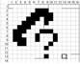
To access the Call Log menu:
- Press the LOG Soft button,
- Use the Navigation up/down keys, to view items (Called, Dialed, or Lost),
01. ▶ CO1 01112345678
02. ◀ 101
03. CO2 LEE K D
04. ▶ KIM M J
05. 103
BACK SELECT SEND ▶
- Log codes include:
◀- Incoming call
▶- Outgoing call
- Missed call
To place a call using numbers stored in the Call Log:
- From the Call Log, use the Navigation up/down keys, to view items (Called, Dialed, or Lost),
01. ▶ CO1 01112345678
02. ◀ 101
03. CO2 LEE K D
04. ▶ KIM M J
05. 103
BACK SELECT SEND ▶
- Highlight the desired item, and press the Send Soft button to place the call.

To access the Call Log menu:
- Press the LOG Soft button,
- Use the Navigation up/down keys, to view items (Called, Dialed, or Lost),
01. ▶ CO1 01112345678
02. ◀ 101
03. CO2 LEE K D
04. ▶ KIM M J
05. 103
BACK SELECT SEND ▶
- Log codes include:
◀- Incoming call
▶- Outgoing call
- Missed call
To place a call using numbers stored in the Call Log:
- From the Call Log, use the Navigation up/down keys, to view items (Called, Dialed, or Lost),
01. ▶ CO1 01112345678
02. ◀ 101
03. CO2 LEE K D
04. ▶ KIM M J
05. 103
BACK SELECT SEND ▶
- Highlight the desired item, and press the Send Soft button to place the call.

To save an external call to the Station Speed dial:
- Use Navigation up/down buttons to highlight the desired external call item,
- Press the Select Soft button,
- Press the Save Soft button.

The CO code in a log item is used to seize the co line when placing an external call using the call log. Up to 5 CO codes can be saved.
The first CO code is sent from the system in the saved call log. Normally the first CO code is ‘9’, but if the telephone number is equal to a number in the Speed Dial list, the first CO code will be the access code of the saved CO line of the speed dial. Therefore the first CO code of each call log can be different and is not be editable.
CO Codes 2 - 5 are the user-defined codes. If a code 2 - is selected, the selected code will be used in placing all of the external calls in the call log.
To select a CO Code:
- From the Call Log, use the right Navigation key, to advance to the next 3 Soft button items,
01. ▶ CO1 01112345678
02. ◀ 101
03. CO2 LEE K D
04. ▶ KIM M J
05. 103
DEL CO CODE
- Press the CO CODE Soft button (code displaying the + symbol is the currently selected item),
1. +88001
2.
3.
4.
5.
BACK EDIT SELECT

To edit the CO code (positions 2-5 only):
- Use Navigation up/down buttons to highlight the desired item,
- Press the Edit Soft button to modify selection.
To select the CO code:
- Use Navigation up/down buttons to highlight the desired item,
- Press the Select Soft button.

- Use Navigation up/down buttons to highlight the desired item,
- Press the Edit Soft button to modify selection.
To select the CO code:
- Use Navigation up/down buttons to highlight the desired item,
- Press the Select Soft button.

Contrast (iPECS-LIK)
LCD contrast can be adjusted to enhance viewing ability.
To change the LCD Contrast:
- While in an idle state, press the VOL  VOL  buttons to adjust the brightness.
- increase (darker)
- decrease (brighter)

Background Music and Music on Hold (iPECS-LIK)
Two audio sources can be connected to the system. These sources or an internal source provide input for Background Music (BGM) and Music On Hold (MOH). In addition, a recorded message from the VMIM can be used. BGM is played over the speakers of the iPECS Phone when the station is idle. MOH is played to callers placed on Hold.
There are four possible selections for BGM and MOH:
1: Off
2: Source BGM1
3: Source BGM2
4. VMIM message
To turn on Background Music:
- Press hold/save to cycle through the BGM selections.

Using Internal, External and Meet-Me Paging
The User can broadcast announcements to other stations and/or external speakers. Stations are assigned to one or more of the Internal Page Zones. The system has two External Page Zones that can be connected to external speakers.
In iPECS-LIK, Page Zone codes are:
Internal Page Zones 501-510 (iPECS 100), 501-535 (iPECS 300 & 600)
Internal All Call Page 543
External Page Zones 545-546
External All Call Page 548
All Call Page 549
In iPECS-MG, Page Zone codes are:
Internal Page Zones :
543 + Zone No(01~15) (iPECS-MG100)
543 + Zone No(01~30) (iPECS-MG300)
Internal All Call Page 543 + 00
External Page Zones 548
All Call Page 549
If the desired Page Zone is busy, the User can elect to be recalled when their turn comes in the queue. Users can also request a paged party answer the Page using Meet-Me Paging. In this case, the paged party may answer the page from any phone in the system by dialing the Meet-Me code.
To make a page:
- Lift the handset,
- Dial the desired Page zone,
- If assigned, after page warning tone, make announcement.
To queue for a page when busy is received(iPECS-LIK):
- Press the MSG button,
- Replace the handset returning to idle.
To answer a Meet-me-Page:
- Lift the handset.
- Dial 544(iPECS-LIK)/546(iPECS-MG) (Meet-Me-Page code).

Push-To-Talk (PTT) Page
iPECS Phones can be assigned as a member of one or more of the system’s nine Push-To-Talk (PTT) page groups. Users separately log-in or log-out of any one or all PTT groups to which the phone is assigned. Once logged in, place or receive one-way page announcements to/from other users who are logged in to the same PTT group.
To log-in to a PTT group:
- Dial #0(iPECS-LIK)/538(iPECS-MG),
- Dial the desired PTT group number (1-9 or 0 for all groups),
To log-out of the PTT group(s):
- Dial #0(iPECS-LIK)/538(iPECS-MG), the PTT Log-in/out code,
- Press the * key.
To place a page announcement to the active PTT group:
- Press and hold the ptt Flex button,
- After confirmation tone, make page announcement.

Wake-Up Alarm
iPECS supports an Alarm clock for each station in the system. The alarm clock can be set to repeat daily or as a one-time alarm.
When responding to the alarm by lifting the handset, BGM will be provided.
To set the Wake Up Alarm clock:
- Press trans/pgm,
- Dial 41(iPECS-LIK)/13(iPECS-MG) (Alarm Clock code),
- Dial 2-digit hour and minute (hh/mm) for alerting,
- For a daily (repeating alarm), press #,
- Press hold/save.
To erase Wake-Up:
- Press trans/pgm,
- Dial 42(iPECS-LIK)/14(iPECS-MG) (Alarm Clock delete code),
- Press hold/save.

Alarm/Door Bell
The system can monitor external Alarm or Door Bell contacts:
Alarm Monitor—should the external contact activate, a unique Alarm Ring signal and LCD display may be received. To restart the monitor circuit, the external contacts must be deactivated and the Alarm Ring signal terminated.
Door Bell—a unique Door Bell Ring (single tone burst) may be received each time the external contact is activated. A system contact also can be assigned to act as a Door Open contact.
To terminate the Alarm signal:
- Dial 565 (Alarm Stop code).
To activate the Door Open contacts:
- Lift the handset,
- Dial Door Open code, #* and contact number 1-4.

NOTE—Contacts 3 & 4 are only available in the iPECS -300 & 600. Contacts 1 is available in the iPECS -MG.

Power Fail Transfer (PFT)
When AC power to the system fails, back-up operation may be provided with back-up batteries or Power Fail Transfer (PFT). When battery back-up is provided the station will operate normally. When PFT is implemented, an SLT is connected to a CO line by the system. This SLT can be used as any normal SLT, providing service while power is out.

System Voice Memo
The integrated Voice Mail modules incorporate several Voice Memos to provide Station Users with general information such as station number, date, time, and feature status. Voice Memos are heard over the iPECS Phone speaker and over the handset for SLTs.
For the Station Status Memo, the following items are reported:
ICM Signaling Mode (Handsfree/Tone/Privacy)
Station IP Address
Station Mac Address
Number of messages x (x: number of all message waiting)
Wake-Up Time (hh:mm)
Do Not Disturb
Forwarded to station xxx
Forwarded to speed bin xxx
Queued CO/IP line xxx
Locked (Temporary COS)
COS x

NOTE—only activated features are announced.
To hear Date & Time memo:
- Dial the Voice Memo code (661 for iPECS-100, or *661 for iPECS-300 & 600, or 675+1 for iPECS-MG),
- Date and Time memo is heard, “Date is May 2nd.Time is xx:xx pm”.
To hear Station Number Prompt:
- Dial Voice Memo code (662 for iPECS-100, or *662 for iPECS-300 & 600, or 675+2 for iPECS-MG),
- The Station Number memo is heard, “This is station 150”.
To hear Station Settings:
- Dial Voice Memo code (663 for iPECS-100, or *663 for iPECS-300 & 600, or 675+3 for iPECS-MG),
- Station Status Memo is heard.

Hot Desk
iPECS phones in the system may be assigned for Hot Desk operation. These Hot Desk phones let you log-on and use the Hot Desk phone as if it were your station.

Once logged-on, the Hot Desk station will take on the attributes assigned to your station number and you can make calls as normal. When logged-out, calls to your station number are forwarded to the chosen destination.
In iPECS-LIK
To Log on to a Hot Desk station:
- Lift the handset,
- Dial your Authorization Code (Station Number and Password).
To Log out of the Hot Desk station:
- Press the trans/pgm button,
- Dial * twice,
- Use the VOL   buttons to select a call forward destination for your calls, speed dial, joined mobile phone, VMIM/VSF, or VM group,
- Press the hold/save button.

In iPECS-MG
To Log on to a Hot Desk station:
- Lift the handset,
- Dial 525
- Dial your Authorization Code (Station Number and Password).
To Log out of the Hot Desk station:
- Press the trans/pgm button,
- Dial 525,
- Input Call forward destination number optionally
- Press the hold/save button.

PBX, Centrex & ISDN features
9. PBX, Centrex, & ISDN Features

Access PBX or Centrex features
The iPECS has been designed to operate with a host PBX system or Centrex services from your service provider. The iPECS connects to a host with analog CO lines.
When accessing a CO line, the phone will act as an extension of the host, allowing access to the host system features using the host dial codes. While on a call, use the iPECS Flash feature to transfer calls to other host extensions or access features of the host.
The Flash feature may be used on other CO lines to regain dial tone from the CO line without relinquishing control of the CO line to place another call.
To access PBX or Centrex features while idle:
- Lift the handset,
- Select/dial access a PBX/Centrex CO line,
- Dial PBX/Centrex feature code.
To access PBX/Centrex features while on a PBX/Centrex CO line:
- Use the Navigation button to display the next menu, and select the Flash soft button,
- After receiving new dial tone, dial the PBX/Centrex feature code.

Access the ISDN Network

Using the Keypad facility to access ISDN features
Access to certain features of your ISDN services requires that dialed digits be sent to the ISDN as data and not tones. In this case, dialed digits are sent as ‘Keypad messages’.
A Keypad Facility button must be assigned using the Flex Button program procedures. Once active, dial into the ISDN for services; however, actions other than dialing will deactivate the Keypad Facility operation.

To activate Keypad Facility operation:
- Press the programmed keypad facility button to switch to keypad mode,
- Dial as desired.
To deactivate Keypad Facility operation:
- Press keypad facility,
- OR
- Press a Feature or Flex button.

Using ISDN Supplementary Services
ISDN service providers may incorporate features similar to those of Centrex. These ISDN Supplementary services are provided on a subscription basis, and as with Centrex, are accessed using the Flash button on an iPECS phone.
Using supplementary services an ISDN line can be placed on Hold and a second call placed on the line. You may then alternate between the two held calls (Broker Call) using the hold button. An ISDN line conference can be established using the Flash and Conf Soft buttons. A conference can also be placed on hold.
While on an ISDN CO line, to access ISDN Supplementary services:
- Press Flash,
- Press Hold/Save, Conf, or CO line button to activate the desired feature.

Activating ISDN Caller ID Restriction
iPECS Phone users can restrict the transmission of Caller ID to the far-end. This may be a subscription service of your carrier. Separate Flex buttons are required to activate outgoing, Connected Line (COL), and incoming, Calling Line ID (CLID) restriction.

To restrict Caller ID:
- Lift the handset,
- Press programmed CLIR/COLR button to place call.

Features & Flex buttons
10. Features & Flex Buttons

Entering Station Program Data
A special code set is available for iPECS Phone users to assign certain attributes such as Authorization Codes (Passwords). After entering the User Program mode, dial the codes to select the attribute and setting. Once selected, the setting is saved. A list of the User Program codes, the feature/function and any input required are given in Appendix B. In some cases, you enter these codes as part of Flex button assignments.
To assign user programmable attributes to your station:
- Press trans/pgm,
- Dial desired User Program codes shown in Appendix B,
- Press hold/save.

Assigning Features to Flex Buttons
You may assign features and functions to the Flex buttons on your iPECS Phone (possibly CO/IP lines).
Flex buttons may be assigned for most features providing One-Touch feature activation (ex., a Flex button may be assigned to access the Account Code feature and may include the Account code digits).
Features that may be assigned to a Flex button include:
DSS/BLF—Enter station number.
Speed Dial—Enter Station/System Speed dial bin.
Flex Numbering Plan—Enter Flex Numbering Plan code (refer to Appendix A).
User Program Code—Press trans/pgm and enter a User Program code (refer to Appendix B).
CO/IP Line—Enter the CO/IP line or group number.
To assign a feature to a Flex button:
- Press trans/pgm,
- Press the desired Flex button,
- Dial desired code and required inputs; for User Program codes Appendix B), first press the trans/pgm,
- Press hold/save.

Appendix A Flexible Numbering Plan
In iPECS-LIK
FEATURE | iPECS-100 | iPECS-300 | iPECS-600 | REMARK
Intercom Call | 100-169 | 100-399 | 1000-1599
Internal Page Zone | 501-510 | 501-535 | 501-535
Internal All Call Page | 543 | 543 | 543
Meet Me Page | 544 | 544 | 544
External Page Zone 1~2 | 545-546 | 545-546 | 545-546
External All Call Page | 548 | 548 | 548
All Call Page (Internal/External) | 549 | 549 | 549
SMDR Account Code Enter | 550 | 550 | 550 | SLT use only
Flash Command to CO Line | 551 | 551 | 551 | SLT use only
Last Number Redial | 552 | 552 | 552 | SLT use only
DND (Toggle On/Off) | 553 | 553 | 553 | SLT use only
Call Forward | 554 | 554 | 554
Speed Dial Programming | 555 | 555 | 555 | SLT use only
Message Wait/Callback Enable | 556 | 556 | 556 | SLT use only
Message Wait/Callback Return | 557 | 557 | 557 | SLT use only
Speed Dial Access | 558 | 558 | 558 | SLT use only
Cancel DND/FWD/Pre MSG | 559 | 559 | 559 | SLT use only
CO System Hold | 560 | 560 | 560 | SLT use only
Program Mode Access | 561 | 561 | 561 | SLT use only
Attendant Unavailable | 562 | 562 | 562
Answering Machine Emulation | 564 | 564 | 564
Alarm Reset | 565 | 565 | 565
Group Call Pickup | 566 | 566 | 566
Universal Night Answer | 567 | 567 | 567
Account Code with bin | 568 | 568 | 568
Walking COS Code | 569 | 569 | 569
ACD Supervisor On/Off Duty | 571 | 571 | 571
ACD Supervisor Login | 572 | 572 | 572
ACD Supervisor Logout | 573 | 573 | 573
ACD Help Code | 574 | 574 | 574
ACD Calls In Queue Display | 575 | 575 | 575
ACD Supervisor Status Display | 576 | 576 | 576
ACD Supervisor Monitor | 577 | 577 | 577
ACD Reroute Queued Call w/answer | 578 | 578 | 578
ACD Reroute Queued Call w/o answer | 579 | 579 | 579
Enter Conference Room | 59 | 59 | 59
Camp-On Answer | 600 | 600 | 600 | SLT use only
Call Parking Locations | 601-610 | 601-619 | 601-619
Group Pilot Number | 620-659 | 620-667 | 620-667
Station User VMIM/VSF Features | 66 | *66 | *66
Call Coverage button | 67 | 67 | 67
Direct Call Pickup | 7 | 7 | 7
CO/IP Group Access | 8xx  01-20 | 8xx  01-72 | 8xx  01-72
Individual CO/IP Line Access | 88xx  01-42 | 88xxx  001-200 | 88xxx  001-400
Retrieve Last Held CO/IP | 8* | 8* | 8*
Retrieve Individual Held CO/IP | 8#xx | 8#xxx | 8#xxx | xx(x) = CO Line number
Access CO Line in the 1st available CO Group | 9 | 9 | 9
Attendant Call | 0 | 0 | 0
VM Message Wait Enabled | *8 | *8 | *8
VM Message Wait Disable | *9 | *9 | *9
Door Open (1st Door ) | #*1 | #*1 | #*1
Door Open (2nd Door ) | #*2 | #*2 | #*2
Door Open (3rd Door ) | #*3 | #*3 | #*3 | iPECS-300 & 600
Door Open (4th Door ) | #*4 | #*4 | #*4 | iPECS-300 & 600
MCID Request | *0 | *0 | *0
AME Feature | 564 | 564 | 564
Unsupervised Conference Timer Extension code | ## | ## | ##
PTT Group Login/Logout | #0 | #0 | #0

In iPECS-MG
1) Basic Number
No | Name | Code | Remark
1 | Station Number | 100 ~ 4xx
2 | CO Group Access Code | 9,  801 ~ 872(MG-300)  801 ~ 824(MG-100)
3 | Station Group Number | 620 ~ 669(MG-300)  620 ~ 639(MG-100)

2) Feature Code
No | Feature Name | Code | Remark
1 | Attendant Call | 0
2 | Conference Room 1 | 571
3 | Conference Room 2 | 572
4 | Conference Room 3 | 573
5 | Conference Room 4 | 574
6 | Conference Room 5 | 575
7 | Conference Room 6 | 576
8 | Conference Room 7 | 577
9 | Conference Room 8 | 578
10 | Conference Room 9 | 579
11 | Internal Page | 543 | 543 + 00, xx  00: All Call Page  Xx: Page Group #
12 | Personal VM Page | 544
13 | Announcement Page For Attendant | 545
14 | Page Auto Answer | 546
15 | Internal Page Answer  (Meet-Me Page) | 547
16 | External Page | 548
17 | Internal-External Page All | 549
18 | Call Forward Register | 554 | 554 + Type + Destination
19 | Pilot Hunt Call Forward Register | 514 | 514 + Type + Destination
20 | Pilot Hunt Call Forward Cancel | 515
21 | DND Status Change | 516
22 | DND Delete | 517
23 | Account Code | 550
24 | CO Flash | 551
25 | Last Number Redial | 552
26 | Station Speed PGM | 553
27 | Speed Dial | 555
28 | MWI Register | 557
29 | MWI Answer | 558
30 | MWI Cancel | 559
31 | Call Back Register | 518
32 | Call Back Cancel | 519
33 | Group Call Pickup | 564
34 | Direct Call Pickup | 7
35 | Walking COS | 520
36 | Call Parking Location | 541 | 541 + xx  Xx: Parking Location  (00 ~ 49)
37 | PGM Mode Access | 521
38 | Two-Way Record | 522
39 | VMIB Access | 523
40 | AME Access | 524
41 | CO Line Access | 88 | 88 + xxx  Xxx: CO Line #  (001 ~ 200 : MG-300  01 ~ 80 : MG-100)
42 | VM MWI Enable | *8
43 | VM MWI Cancel | *9
44 | MCID Request | *0
45 | Unsupervised Conf Extend | 5##
46 | PTT Group Access | 524 | 524 + (0~9,*)  0 ~ 9: PTT Group #  *: Log out
47 | Hot Desk Log In/Log out | 525
48 | Name Register | 526
49 | Create Conf Room | 527 | 527 + Conf. Room #
50 | Delete Conf Room | 528 | 528 + Conf. Room #
51 | Wake Up Register | 529 | 529 + HH:MM
52 | Wake Up Cancel | 530
53 | Temporarily COS Down | 531
54 | Cancel Temp COS Down | 532
55 | Password Change | 533
56 | Inter-Phone Group Access | 534
57 | Call Wait Request | 535
58 | Preselected MSG PGM | 536
59 | Forced Handsfree Call | 537
60 | Call Based CLIR | 582
61 | CLIR Access | 583
62 | COLR Access | 584
63 | Pilot Hunt Call | 585
64 | Command Call Oneway | 581
65 | Command Call Conf | 580
66 | Intrude Register | 589
67 | Camp On Register | 590
68 | OHVO Register | 591
69 | Mobile Num Register | 592
70 | Mobile CLI Register | 593
71 | Mobile Access | 594
72 | CCR Access | 670
73 | CCR Access And Drop | 671
74 | System Hold | 560
75 | Return Held CO | 8**
76 | Sys Memo | 675
77 | DISA Tone Service | 678
78 | All Feature Cancel | 679
79 | Add Conf Member | 680
80 | System Alarm Reset | 565
81 | Fault Alarm Reset | 566
82 | Door Open | #*1
83 | Keypad Facility | ##*
84 | T-Net Log-In/Out | 586
85 | Universal Answer | 587
86 | USB Call Record | 588
87 | Delete All VM Message | 681
88 | VM Page Message Record | 682
89 | Direct VM Transfer | 683
90 | Loop Key | 684
91 | Call Log | 685
Appendix B User Program Codes
In iPECS-LIK
CODE | FUNCTION | REMARK
10 | Enblock Mode Dialing | iPECS LIP-7000 only
11 x | Differential Ring, Intercom | Select Ring Tone 1-8
12 x | Differential Ring, CO/IP line | Select Ring Tone 1-8
13 x | Intercom Answer Mode | Select ICM Signal mode,  1: HF, 2: TONE, 3: Privacy
14 x | Call Coverage Attribute Setting | 1+: ON/OFF, 2+: ring delay (0-9)
15 x | Station Ring Download | Select download Ring Tone 0-9
19 | Ear&Mic Headset Usage | iPECS LIP-7000 only
21 | Knock Down Station COS
22 | Restore Station COS | May require Authorization code
23 | Walking COS | May require Authorization code
30 | VM Mobile Notify
31 | Station Message Wait Retrieve
32 | CLI/IP Message Wait Retrieve
33 x | Authorization Code (Password) Entry | Station number +up to 12 digits, no Flex button
34 | Assign DID Call Wait Button
35 | Message Wait in Executive/Secretary pair
36 | Send SMS Message
37 | Register Mobile Extension
38 | Activate Mobile Extension
39 | Register Mobile Ext. CLI
41 xx | Set Wake-Up Time | Input time, 24 hour clock
42 | Erase Wake-Up Time
51 xx | Custom/Pre-defined Message Display | Select Message 00-20
52 xx | Register Custom Message | Input up to 24 characters
53 x | Create Conference Room | Input Conf Room (1-9) & password
54 x | Delete Conference Room | Input Conf Room (1-9) & optional password
55 | Monitor Conf. Room
61 x | Headset/Speakerphone Mode
62 x | Headset Ring Mode | 1: Speakerphone, 2: Headset, 3: both
71 | LCD Display Mode
72 | Version Display
73 | Background Music
74 x | Station User Name Registration | Input up to 12 characters
75 | Display Phone IP Address
76 | Change Phone IP Address
77 | Display Phone MAC IP Address
78 | Change Mode
79 | Display Phone Version
80 | Assign Record Button | Requires VSF/External SMDI VM
81 | Assign ISDN CLIR Button
82 | ISDN COLR Button
84 | Assign Account Code Button
85 | Assign LOOP Button
86 | Assign ATD Intrusion Button
87 | ICM Button
88 | Assign Camp-on Button
89 | Assign Keypad Facility Button
8# | Assign OHVO Button
91 | Conf Button Assignment
92 | Call Back Button Assignment
93 | Dnd Button Assignment
94 | Flash Button Assignment
95 | Mute Button Assignment
96 | Monitor Button Assignment
97 | Redial Button Assignment
98 | Fwd Button Assignment
99 | Assign PTT Button
*0 | Hot Desk Login Code
** | Hot Desk Log out Code
*7 | Force Fwd to Dest.
*8 | Register Bluetooth
*9 | Bluetooth Usage

In iPECS-MG
Code | Function | Remarks
11 | Intercom Answer Mode | 1:H, 2:T, 3:P
12 + Name | User name creation | 2 digit for each character
13 + Time | Set wake-up alarm time | HH/mm,  24-hour clock
14 | Cancel Wake-up Alarm
15 | Set language for the display | 00-14
16 | LCD Date Mode Change | DD/MM/YY or MMDDYY
17 | LCD Time Mode Change | 12 Hour/24 Hour
18 | Set Backlight | 0-2
21 | ICM Ring Type
22 | TRK Ring Type
23 | Ring Download | LIP-Series Only
24 | Back Ground Music
31 | Temporary COS | Auth. Code required
32 | Retrieve COS | Auth. Code required
33 | COS Override  (Walking COS) | Auth. Code required
34 | Register Password
35 | Call Log Protect
36 | SMS Message Protect | LIP-Series/LDP6000-Series
41 + MSG number [xx] | Set Pre-defined Message. | 0-9, MSG  *: User Custom # Deactivation
42 | Create a Station User Message
43 | Send SMS Message | LIP Series/LDP6000 Series
44 | Receive SMS Message | LIP Series/LDP6000 Series
51 + x | Activate a mobile phone | X=1-2
52 + x | Register the mobile number | X=1-2
53 + x | Register the mobile CLI number | X=1-2
54 + Rm & Auth Code | Start a Conf Room
55 + Rm & Auth Code | Close a Conf Room
61 | Speaker/Headset Mode | Speak/Headset/E-MIC
62 | Headset Ring Mode | Speaker/Headset/Both
71 | Register Station ICLID
72 | View Station ICLID
81 | View IP Address | IP Phone/ DTIM/SLTM
82 | View Mac Address | IP Phone/ DTIM/SLTM
83 | View IP Phone version
80 | Network Setting | LIP Series
91 | System Version
92 | System IP Address

www.lg-nortel.com

©2008 LG-Nortel Co. Ltd. All Rights Reserved.

